DIPL.ING. PETER W Ü R I N G E R
ZIVILINGENIEUR FÜR MASCHINENBAU

STREITMANNGASSE 17 A-1130 WIEN

AUSTRIA EUROPE
TELEFON +43/1/888 21 21
TELEFAX +43/1/889 26 25
e-mail ziviling@wueringer.net

Datei /tmp/in/input.doc

Adjusting my Locomobile engine

Dear friends in steam,

After purchasing my little steamer I was happy that grinding the cylinders and reproducing pistons with new rings and piston- and valve-rods turned the engine into good running condition. It made a lot of fun to me as you can see at the download
http://www.stanleysteamers.com/photoalbum/wuringer/Locomobile-2005-Englisch-klein.pdf

But after running the car for some hundred miles I decided to make a thorough look into the engine for any wear or miss adjustment.

Unfortunately you have to open the isolation to look into the valve-housing. I used Limpet isolation from the Belgium Company Nestaan as you can see at www.nestaan.nl/uk/thermica.html and it is rather simple to repair this opening.

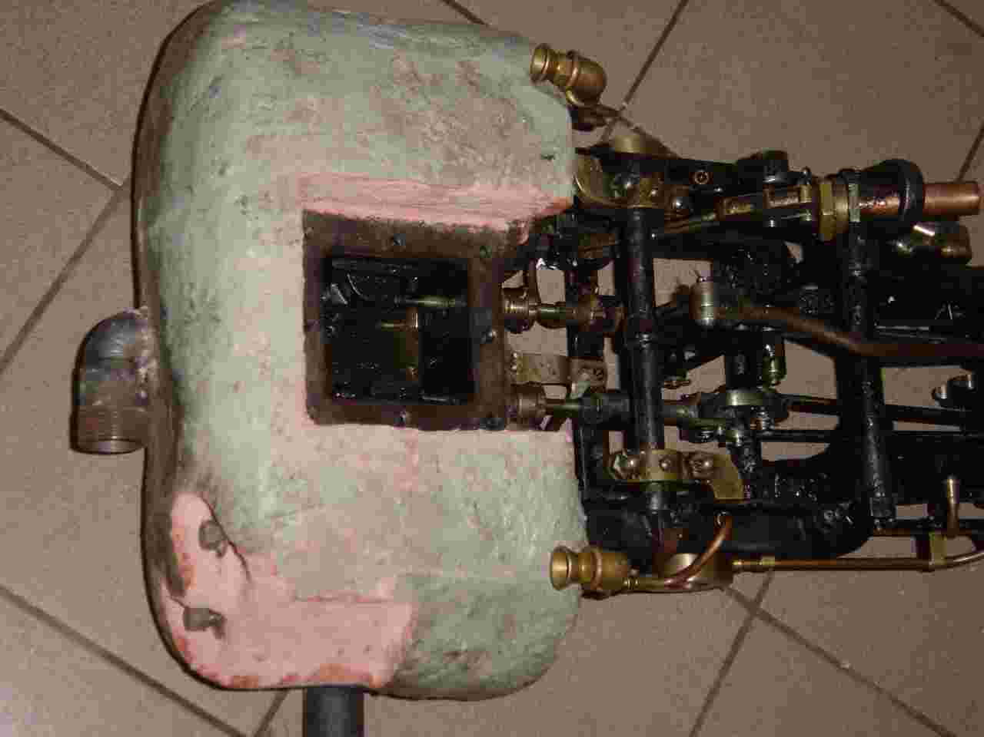

First I thought that it is much important to have the piston operating in the middle of the cylinder, seen in axial direction, but this is not necessary as the valve-steering is very rough at this engine. The piston should be adjusted roughly in the middle of the cylinder with the adjustment at the crosshead. It is much more important that the valves operates in the middle of the cylinder, also seen in axial direction, as you can learn from a very helpful download at http://www.tcsn.net/charlied/valgr10a.zip If you extract the zip-file and open then you can learn much about the valve system. If the reverse arm is in middle position the D-valve should not open the inlet in any position, either at the upper or lower end position of the piston.

This can be easily adjusted with the help of the valve rod and the extra nut to fix the active length of the valve rod in the sliding guide.

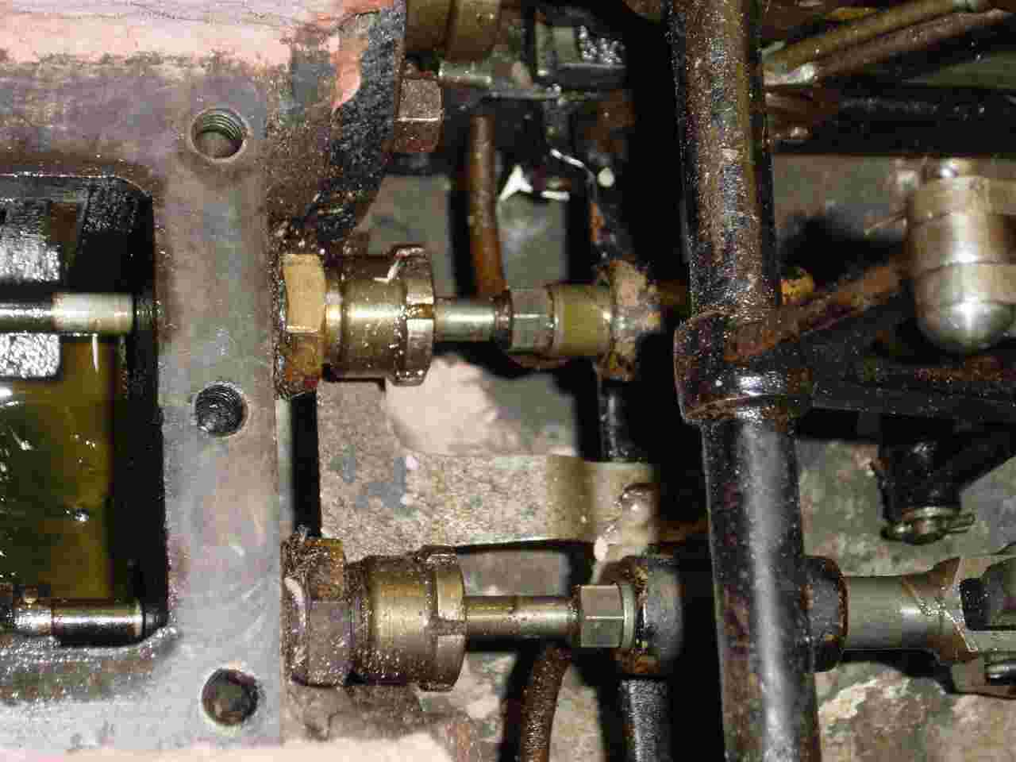

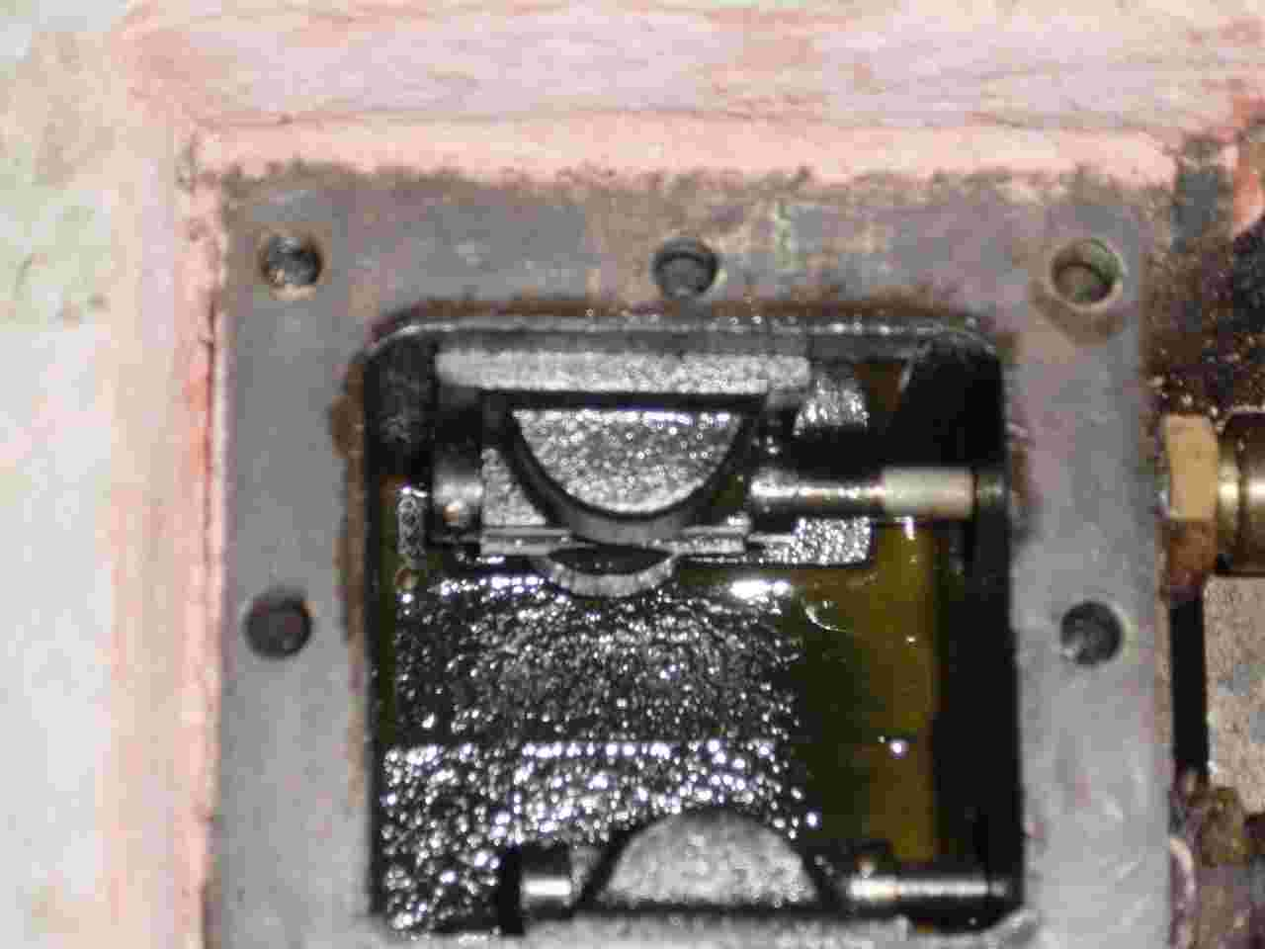

So the Stephenson steering doesn’t open the inlet valve at the top position of the piston just for a short time but opens it half the stroke. This means, that the vapor is not much expanding in the cylinder but just presses down the piston. Therefore the engine is very much ineffective as the steam comes out at the outlet still with high pressure, loosing its energy in the muffler and not working in a second stage as in a compound engine. Now I can understand why there is so much fuel consumption for such a poor horsepower-rating, but this is another problem with steam engines.

The next was repairing of the main and crank bearings. It was rather difficult to fix the crank in a lathe to grind the rings of these ball bearings. But the effect was perfect. With new steel balls the bearings can be adjusted with little clearance running very smooth.

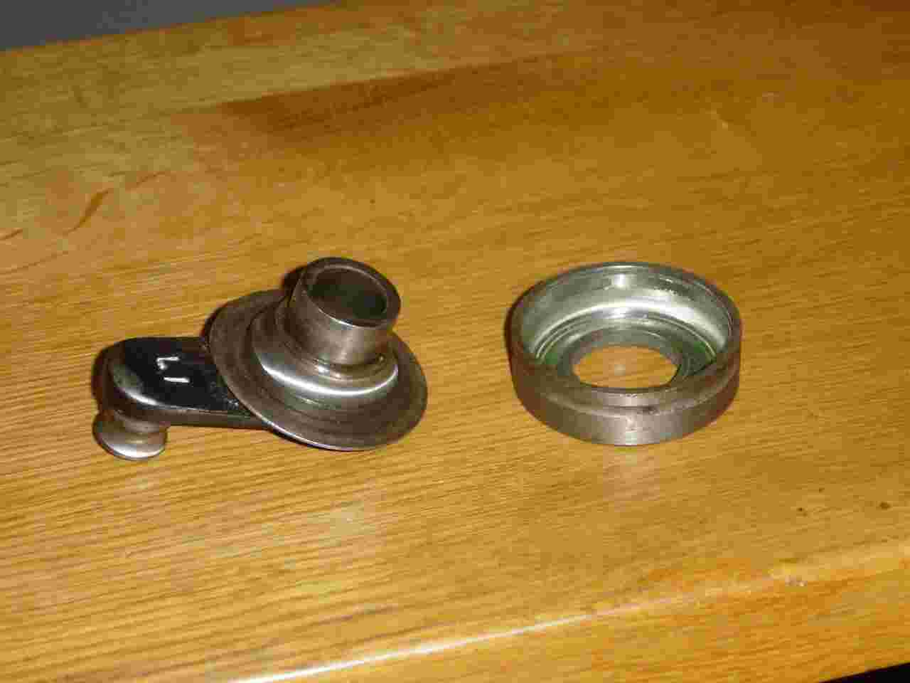

An important thing is that you have to screw the crank rather strong to the crankshaft; this is not for adjustment but for fixing. Therefore I cannot understand, why Ingenieur Ferdinand Brunnbauer, who “restored” my engine in 1905, made this fixing adjustable, I hope he made this just for fixing the screw in tightened position.

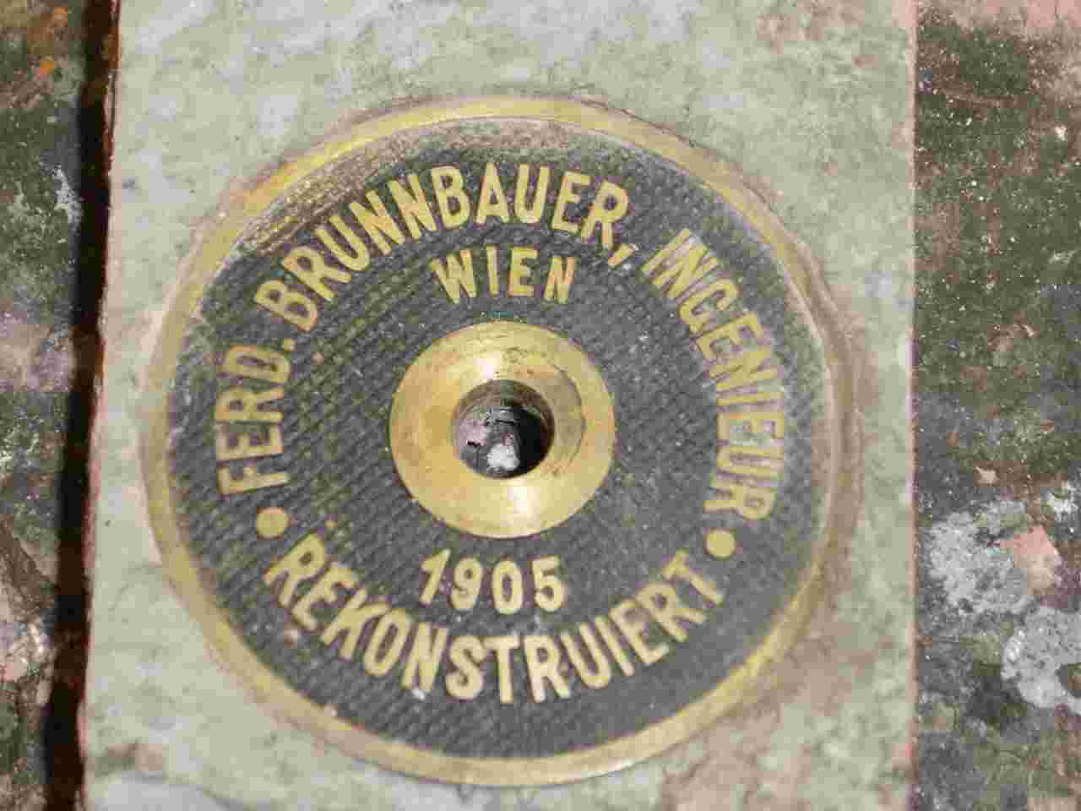

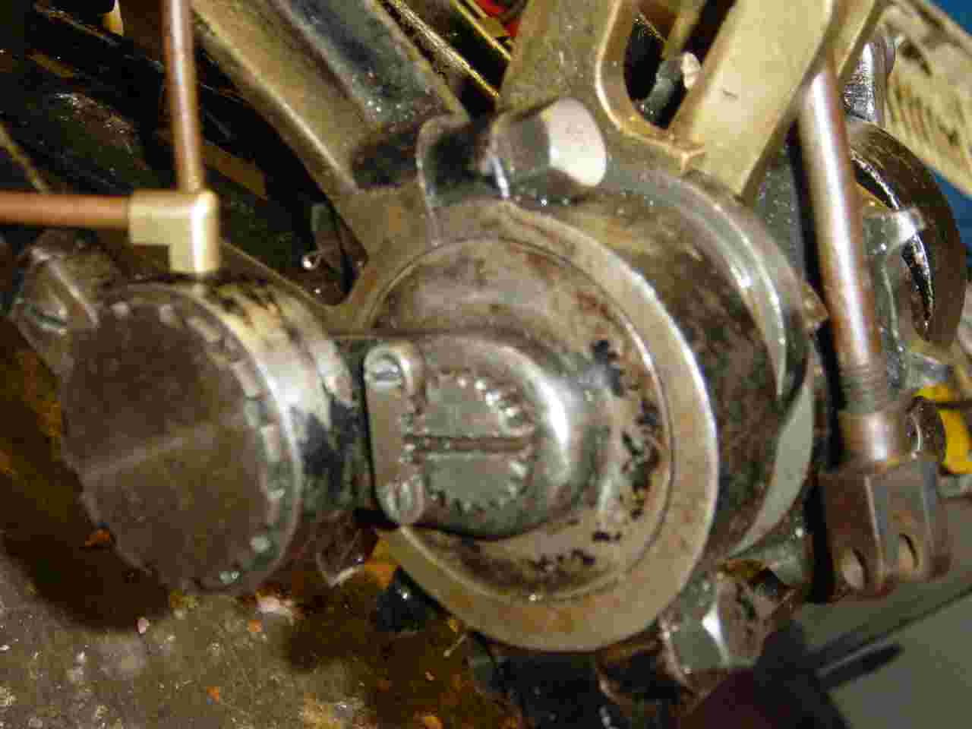

The adjustment of the main bearings is by turning the left-and-right-thread-screw at the lower end of the frame which causes the two sides of the frame spreading wider or getting nearer together

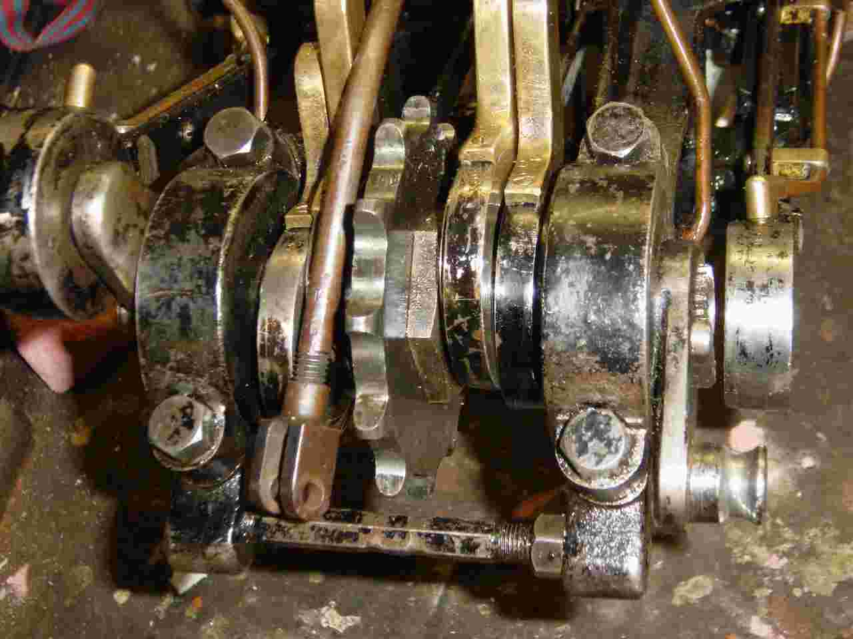
The last thing is to adjust the crank-bearings which can be done easily with the adjustable outer ring of the bearing which also closes the bearing to outside.

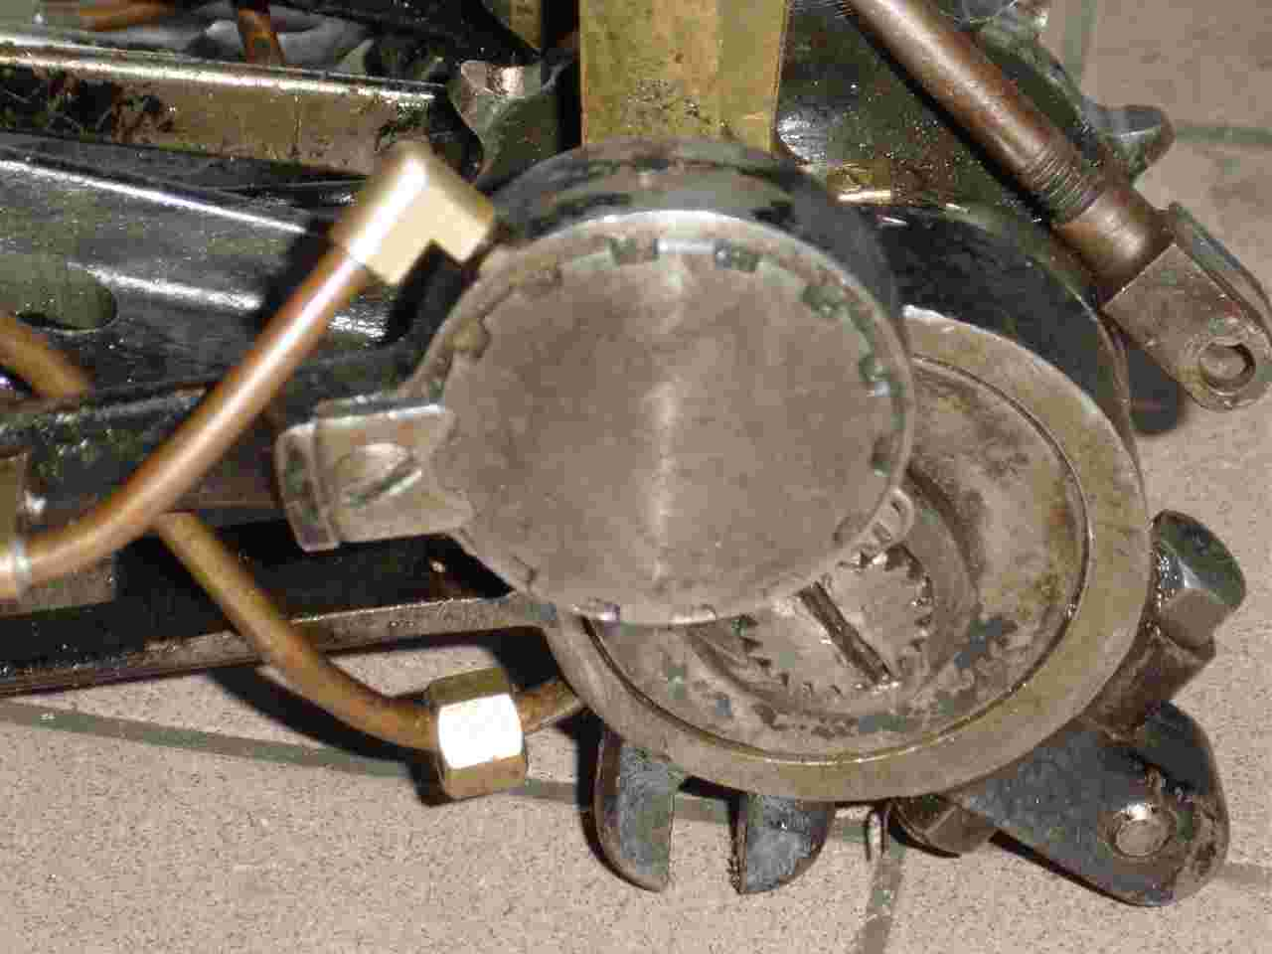

So the engine will be ready for the next trips, especially the steam car meeting in Melle, northern Germany in May and then the Exelberg memorial in Vienna, which my car won 105 years ago.

But there are still some problems which maybe solved with the help of US friends in steam:

As you could read above, I had to reproduce the piston as one of the original piston-rings was broken and I couldn’t get a spare one. The original pistons of the engine are of the shorter type with 2 parts not the longer type pistons with 3 parts as you can see at the right side of the following picture. This longer piston comes from my spare engine with longer cylinders.

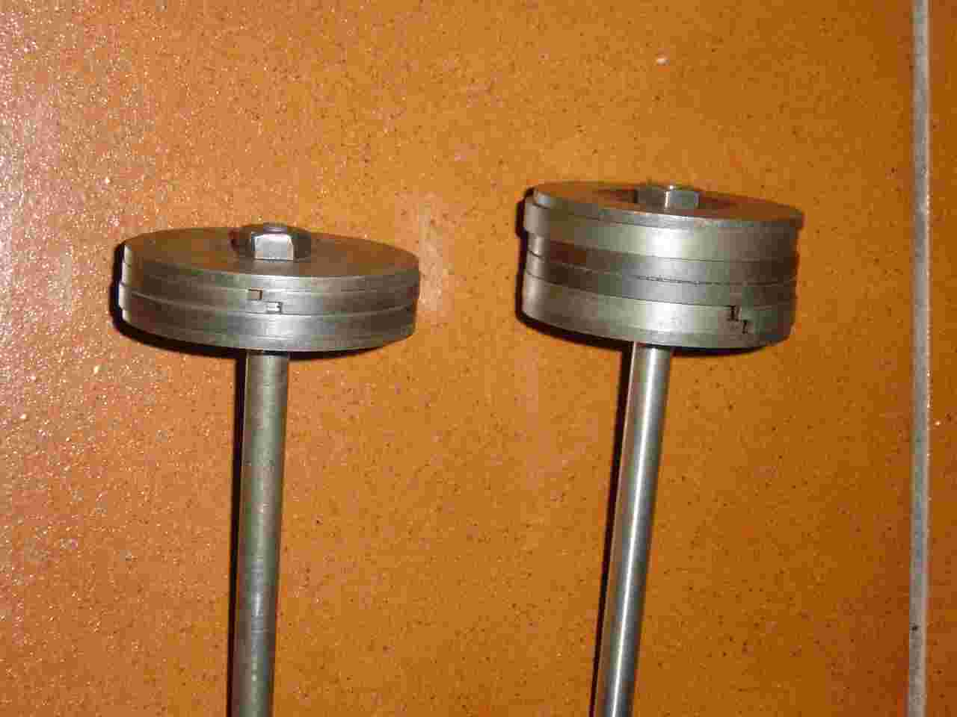

The rings are special construction for steamers with overlapping ends for smaller leaking. Cylinder diameter is 2 1/2” and the rings should be 0.182“ thick.

Who knows where to get spare rings?

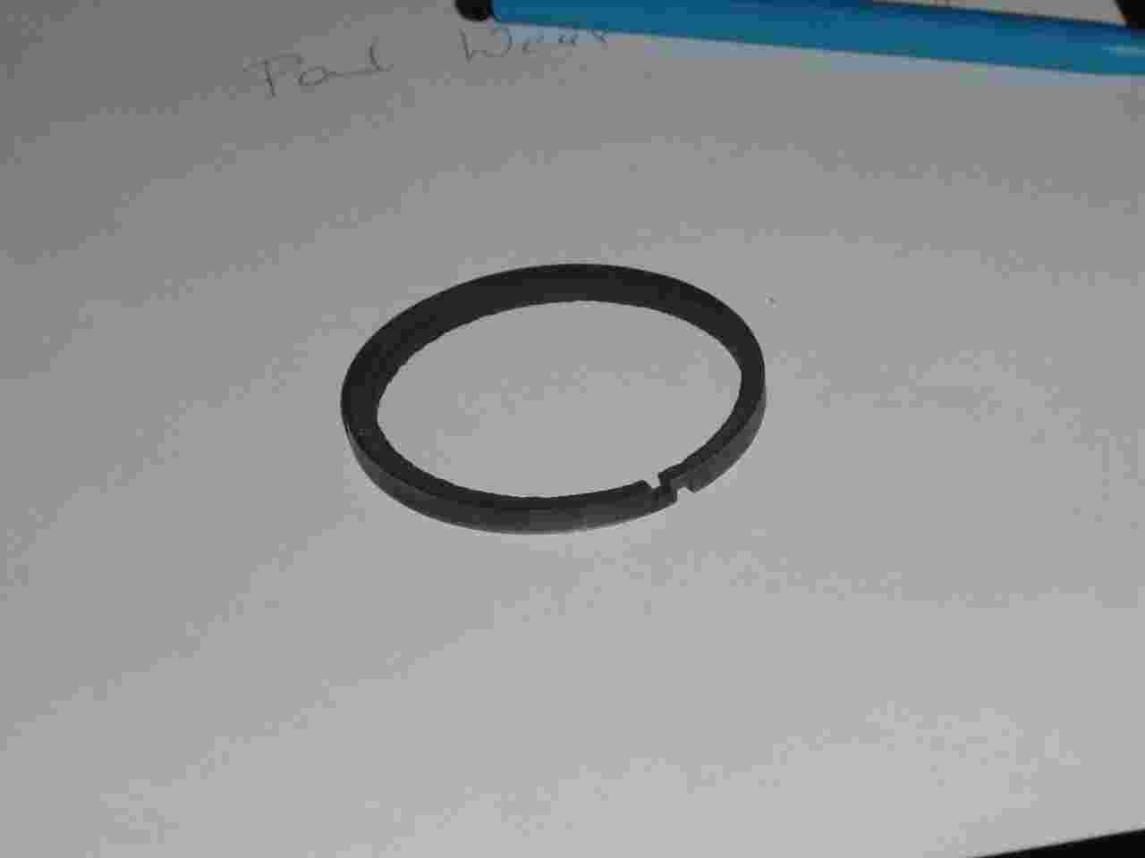

Another thing are oilers for the rear axle. I can buy similar oilers in Austria only with metric thread and another type of cap, but not the special form with UNC 1/4" x 28

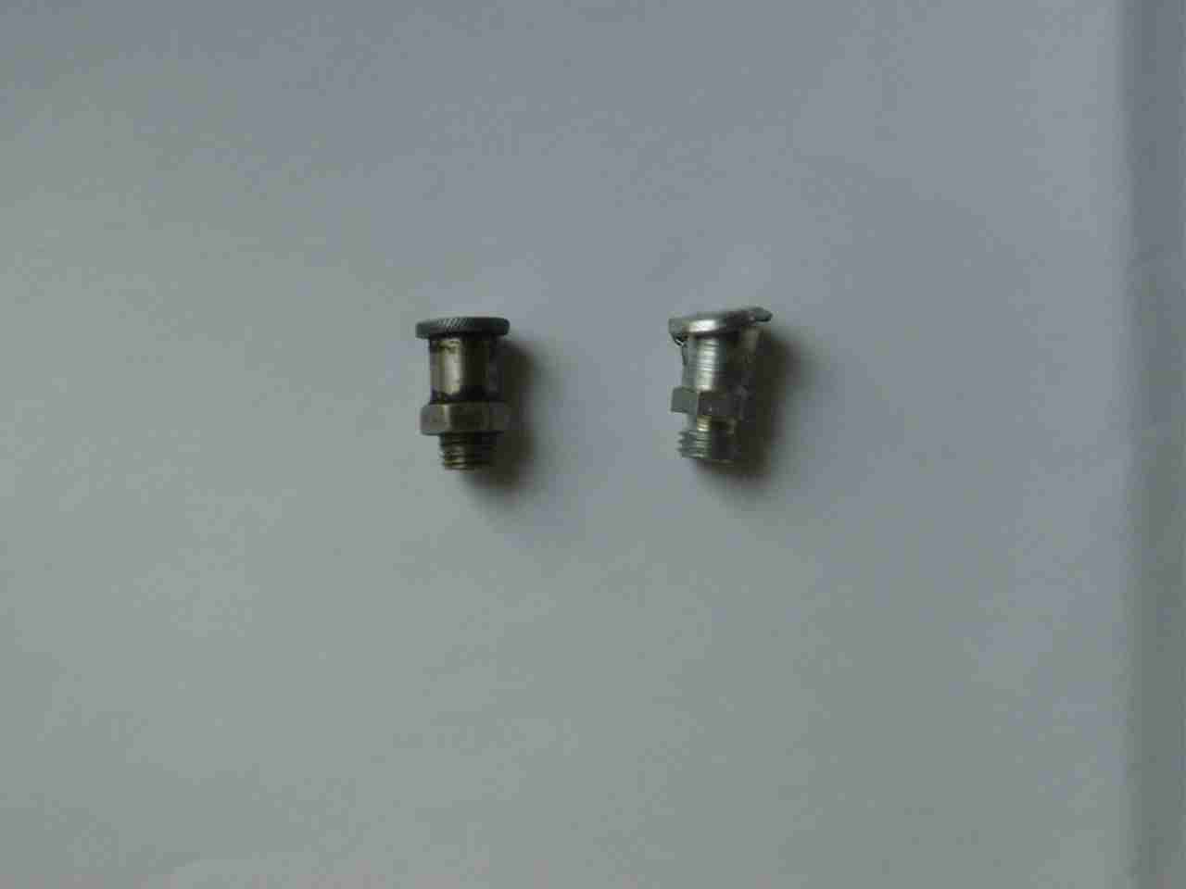

Different problem I have with these clips for mounting the tool flap to the car. Don Ball described them as similar to those used on galoshes. I could get similar ones at a shoemaker’s shop just before he retired but they have to be sewed to the leather stripes and not riveted as seen on the one original clip surviving with my car.

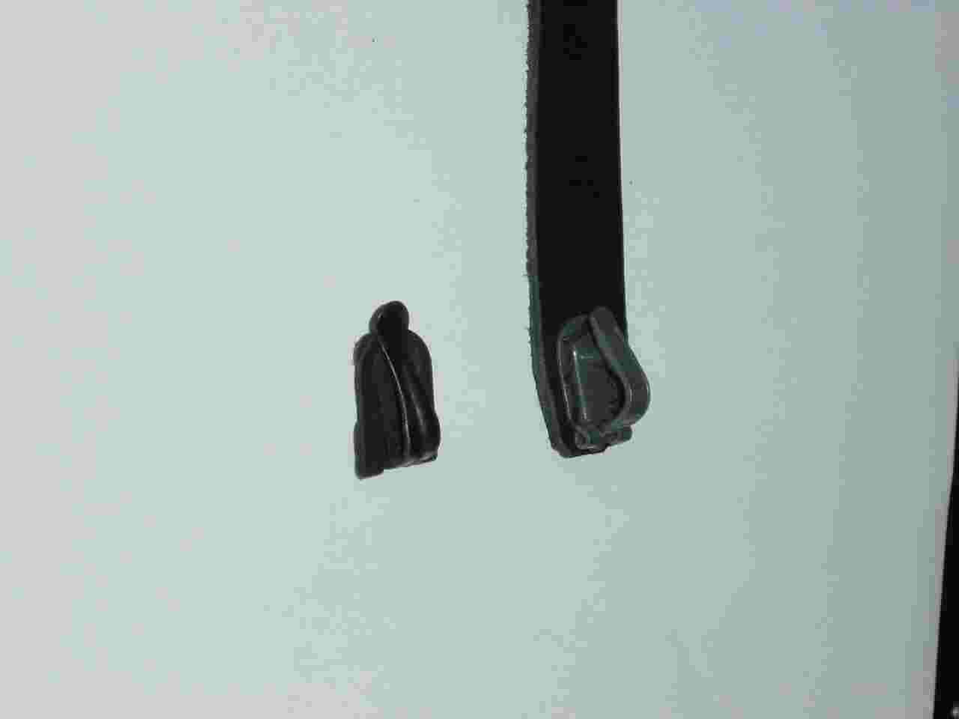

Also a spare part of block chain, one or two feet long, with some chain links would be very helpful. I could find this chain at
http://bostongear.com/pdf/bearing_catalog_sections/bearings_178-182.pdf at page 179 but 25 feet minimum length means a lot of money.

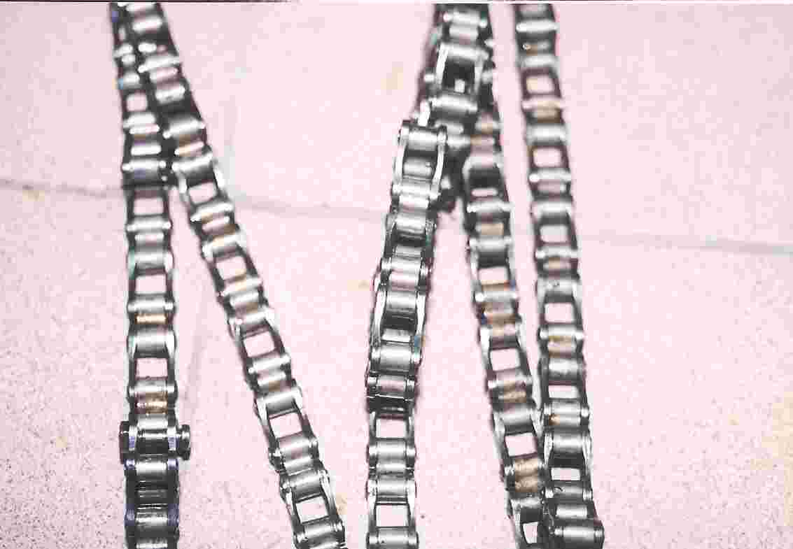

One more question: How to mount the Veeder odometer to the front axle? I bought a Veeder odometer at ebay and fixed it with a bicycle odometer bracket but it didn’t work, I lost it and found it smashed by a following car. So I bought another antique Veeder odometer at ebay but I am using just a modern plastic odometer made in Czech Republic with the same shape as Veeder because the bracket is not very reliable.

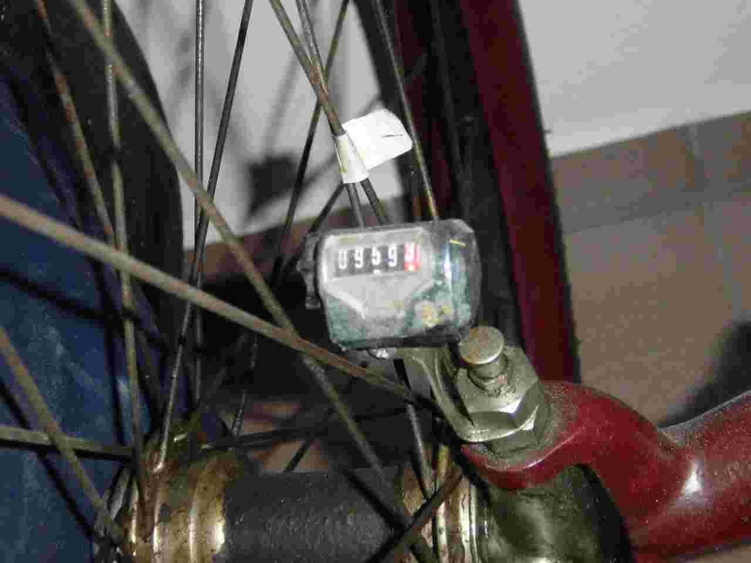

Something different: Who knows what these oilers are used for? I got them with my spare engine and cannot use them in any way. The big one is from Michigan Lubr. Co Pat. Feb 1880 and the small one is from SWIFT Lubricator Co, ELMIRA N.Y. Pat Mar. 21 1882

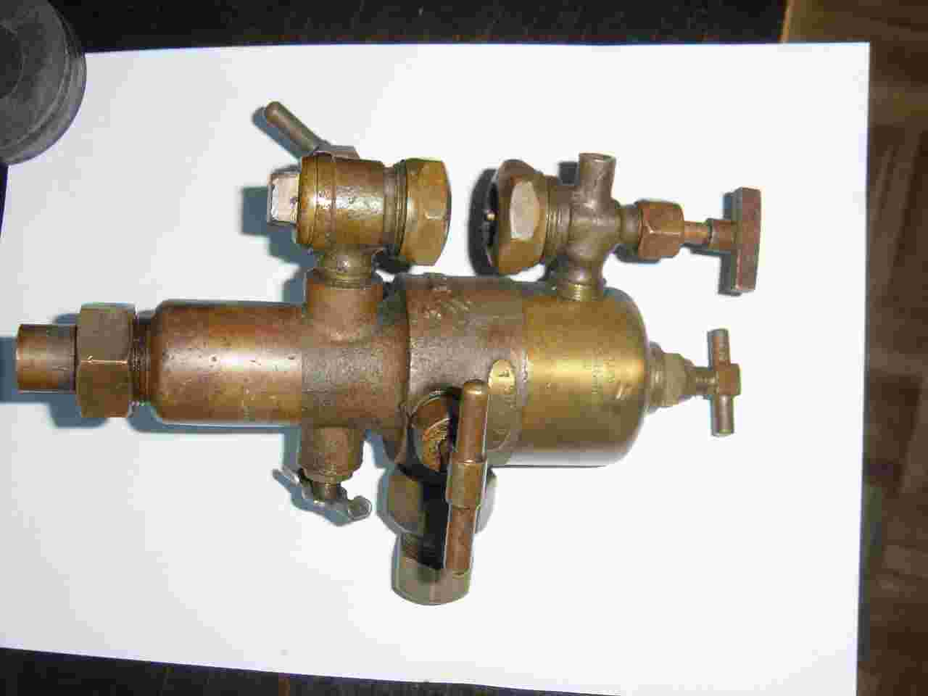

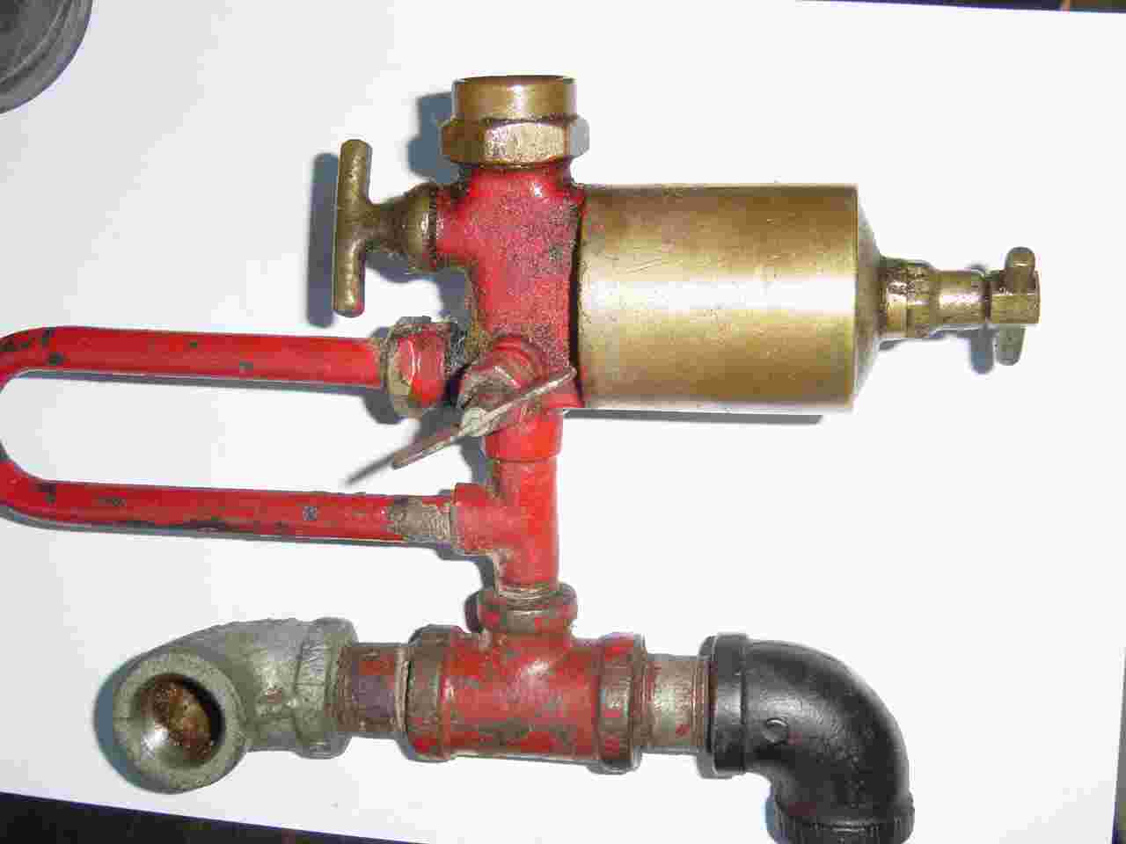

And this I was told it should be a part of a pilot burner, who knows about it?

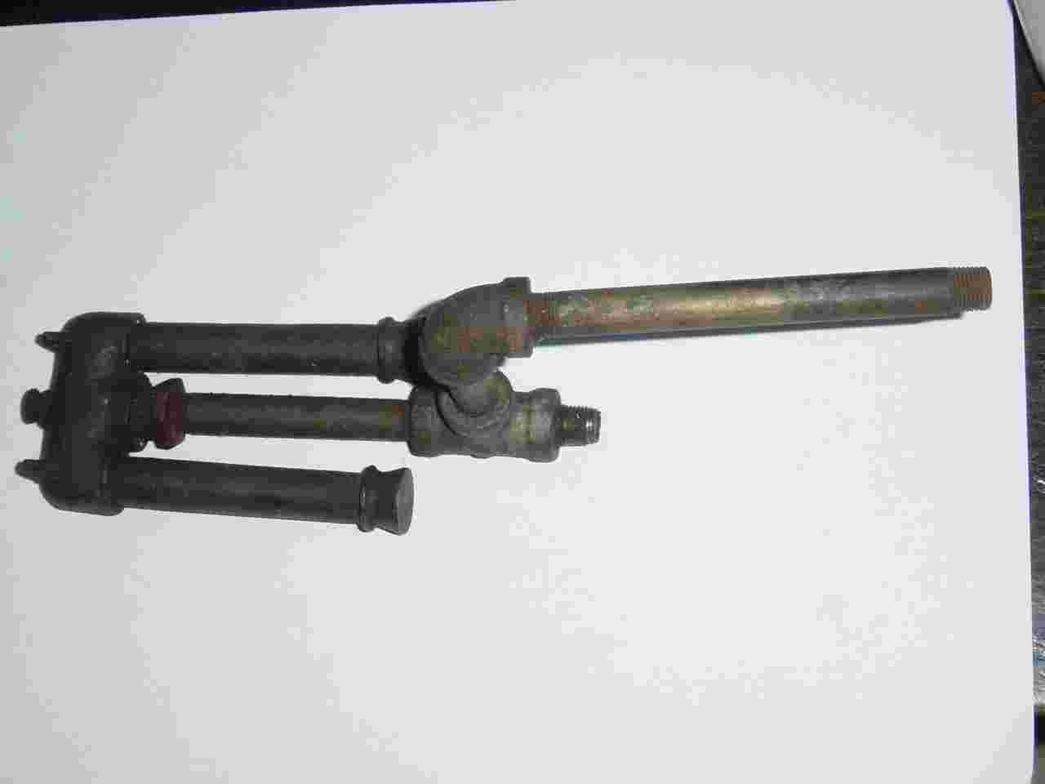

Please apologize my poor technical English but as you know from Arnold Schwarzenegger, Austrian people have problems with your language. I hope somebody will reply to this mail ziviling@wueringer.net offering his help to the missing parts mentioned.

With best wishes for the rest of this year under full steam pressure,

Peter Würinger from Vienna, Austria

