THE MODERN STEAM ENGINE
THE APPLICATION POTENTIAL FOR USING THE
SCHOELL CYCLE REGENERATIVE ENGINE IN THE AUTOMOBILE.

By James D. Crank 1-16-12-f

PREFACE.

Over the last 250 years, steam engines ushered in the American Industrial Revolution, powered
our factories, drove the locomotives that fueled our Western Expansion and powered ships that navigated America’s rivers and coastlines well into the 20th Century. Steam built this country and today, steam remains the driving force behind over 60% of our nation’s electricity production – natural gas, coal and nuclear power plants run on massive Rankine cycle steam turbines, as do our nuclear submarines and ships for the U. S. Navy.
Recent and dramatic advances in steam engine technology utilizing new materials, unique designs and creative processes such as extensive heat regeneration and water lubrication have made these engines smaller, lighter, more powerful and more efficient than ever before. Today, steam engines again have the potential to power cars, trucks, busses, trains and other forms of modern transportation in ways that are simpler, cleaner, quieter and less reliant on fossil fuels than current practical alternatives. The problem has never been the Rankine cycle itself; but the application of it via the hardware to produce efficient power.

The reader must understand the very basic fundamental difference between the internal combustion (IC) engines and the external combustion (EC) steam engine. In the IC engine power is produced by combustion of the fuel inside each cylinder and it is a cyclic event with varying pressures and temperatures throughout the pistons power stroke. In the Rankine cycle steam engine, the power is produced in the steam generator by burning the fuel at a constant rate and constant temperature with low air pressure and a long term residence time for the fuel particle. Harmful pollution is under complete control and is not present in a correctly designed burner without ANY pollution control hardware at all, a most unique feature only found in the Rankine cycle steam engine and the Stirling cycle hot air engine.
Being external combustion, these two engines are able to burn any fuel that can be supplied to the burner.

The engine, or more accurately described as the expander, is not the actual power source that is elsewhere in the steam generator. Also, the actual power level the steam engine will produce is determined in part by this available steam pressure and temperature. The expander is factually only the converter for transforming heat energy seen as hot steam pressure from the steam generator into shaft power.
Identical to the way the battery electric car also stores its power as chemical energy in the battery with the electric motor acting as a converter to change this chemical-electrical energy to shaft power.
This also is also the reason why the Rankin cycle steam engine produces such large starting torque. The EC engines averaged cylinder pressure (Brake Mean Effective Pressure) is controlled by the initial steam pressure and the amount entering the cylinder on each power stroke and not by the changing conditions inside the cylinder which only last for milliseconds as in the IC engine, the explosion of the fuel-air mixture, but on a controlled longer term basis which the steam engine employs. These are two very different operating conditions and are described in detail further in this paper.

It is also important for the inquiring engineer to understand that while IC engine design is a very well established science, efficient Rankine cycle engine design has now entered a totally different phase.
Early work on vehicle steam engine systems since the turn of the 20th Century ranged from 15% to perhaps 23% net cycle efficiency. In the world today that is just not sufficient to encourage a return look at the cycle for vehicle propulsion, it has to be a lot better, it has to be competitive to existing IC engines. This, as will be examined in this paper, is what prompted the Cyclone engine development, combined with a global warming situation and a need to drastically reduce foreign oil consumption for transportation purposes. The cycle itself does offer more than sufficient gains to encourage a very serious re-examination and a return. This is what the Cyclone Rankine cycle engine has now made attractive and definitely possible. The return application of this cycle cannot be neglected any longer.

This paper is written to explore and discuss the possibilities of applying the modern Rankine cycle steam engine to the automobile, interstate truck and other vehicles. With the design and material improvements available today, the Rankine cycle engine cannot continue to be ignored as a mobile power source. One such engine developed by Cyclone Power Technologies, the Schoell cycle engine, of all the steam systems proposed, offers the most advanced form and presents the most competitive net cycle efficiency to any IC engine and could be the closest to production. It is not a wishful proposal; Cyclone’s Schoell cycle engine is a working reality with important funded contracts in house and continuing development and dynamometer testing refining the design.

Finally, this author would like to thank certain individuals who have helped make not only this paper, but also more importantly modern steam a reality. Harry Schoell, the consummate inventor and namesake for the Schoell cycle engine, is someone I’ve known and watched with interest for a number of years and who initiated the writing of this paper.
Mr. Schoell may have just brought more to the practical development of modern steam technology than anyone in the past three-quarter century. One approach that was studiously avoided and which has doomed so many wishing to improve the Rankine cycle steam engine, was the vaporous imagined theoretical approaches that many past academics and corporate managements have used and totally failed to achieve, just because of a total lack of any real experience and even real knowledge about these engines. Mr. Schoell took the firm position that the work was based on practical hands on experience and assembled a Board of Advisors that had the knowledge to assist in this direction needed for success.

He took a very important approach today when deciding to work with the Rankine cycle steam engine, with the guiding direction of reducing global warming and economically operating on U. S. produced carbon neutral fuel. There is continuing debate whether global warming is a natural long period event or is being accelerated by mankind. What the eventual truth will be is not being debated in this paper, only to state that it does seem to be accelerating and what we can do to slow down this condition is worthy of being done on a worldwide basis. The use of fuels other than petroleum is also not debated, we are consuming this natural resource at a great rate and substitution is also worthy of being implemented.
One paramount consideration was that the potential inherent in the Rankine cycle engine has never been fully optimized nearly as much as it must be to become a competitive power source today for the automobile and truck. Mr. Schoell identified each of the previous features and operating parameters that apply to this power source and also what was not optimum and where research and improvement was demanded to bring the engine into the 21st century. He then proceeded to fund and implement those improvements with seriously advanced design, working experimental hardware and a firm commitment to succeed. He formed the company Cyclone Power Technologies, Inc. to enact this work.

Harry Schoell is not alone in this quest for improving the Rankine cycle steam engine a few others also share this goal. Experienced steam car engineers who also know as fact that the steam engine has enormous potential providing it is developed along these improved lines. His team of technical advisors includes some of the most proven, respected and knowledgeable people in the field, including Robert Edwards, a former fellow engineer from Lockheed-Martin, and George Nutz, whose work with steam cycles over the last 50 years is unrivaled in the field. George did much of his early work on steam at the MIT Instrumentation Laboratory, part of the Department of Aeronautics and Astronautics, and represented MIT-IL at the Department of Transportation Clean Air / External Combustion hearings in the late 1960s. In the spirit of full disclosure, this author also serves as an enthusiastic technical advisor for Cyclone’s Schoell cycle engine. One must also thank the people that have fought to keep steam automobiles in the public eye such as Tom Kimmel, the President of the Steam Automobile Club of America, Jay Leno whose collection of antique steamers this author knows very well and the hundreds of steam enthusiasts worldwide who study, build, drive and collect these fascinating vehicles.

THE APPLICATION OF THE RANKINE CYCLE TO AUTOMOBILES.

The steam powered automobile has existed since the very genesis of that form of transportation. At the turn of the 20th Century, steam was the desired power source. It was understood, used and accepted worldwide in all sizes and applications including the steam engines that powered factories, ships, cars and locomotives. If you wanted a high power output, then steam was the only possible choice. By then, electricity was becoming a serious contender; but not yet up the power levels demanded by industry.
On the contrary, the internal combustion engine (IC) was a cantankerous and unreliable power source until the various automobile manufacturers took the technology under intense development and one by one eliminated the problem areas such as the hand crank starter, carburetion with all of the sophistication of chicken watering troughs, lubrication by dip hope and pray, primitive ignition and low engine efficiency and poor reliability. The IC engine soon became the accepted prime mover for vehicles and the steamer was relegated to the background, except for a few companies and enthusiasts who refused to bow to this way of thinking and to abandon the features that only steam offered.
Why was this? An often repeated statement was that a driving goal was to get reliable power from this one lump of iron and not the collection of components all strung together with yards of plumbing. Then having to wait until the boiler got up steam was another, crank the engine to life and away you go was a serious inducement.
Today that dream of a good and modern steam car is still alive and active in the hands of many enthusiasts worldwide. It is an achievable goal that refuses to go away, nor should it.

The steam powered automobile as it exists now has not benefited to any major degree from engineering improvements, technological advances, or the application of many of the new materials available since World War II, not really in all respects. Most of the recent modern steam projects have only employed Band-Aids and some detail advances in specific areas to what is still basically a 19th Century technology. A few proposed steam systems that this author has witnessed being promoted, border on the technically absurd. The numbers of seriously wrong concepts that are floating around are simply astounding to witness. Quite frankly, these legacy steam power systems, utilizing antiquated technology and materials, will not begin to provide the pollution control, fuel efficiency, simplicity, reliability, power density and compactness required to ensure commercial success today. They are best left as most interesting hobby subjects to be enjoyed for what they represent. A brisk run in a fine restored vintage Stanley or White steamer or a serene cruise in a 19th Century steam launch are most certainly very enjoyable. Events to be remembered and savored for a long time.

What was necessary was a total objective review in all areas of Rankine cycle engineering – a clean sheet of paper with detailed concentration on advancing the work in specific problem areas.
In the opinion of this author, Cyclone Power Technologies has done this to a greater extent than any other developer known or reviewed and the developments introduced in the early prototypes of Cyclone’s Schoell cycle engine are showing a dramatic improvement over Rankine cycle engines of the past.

THE RIGHT QUESTIONS AND REALISTIC ANSWERS.

Questions that we should be asking with respect to automotive power sources are which ones are really practical, reliable, cost effective, and acceptable to the car-buying motorist, what will he willingly spend his money on? Which ones truly address the greatest environmental problems of our time, and allow our nation to wean itself off the use of traditional fossil fuels that increasingly come from volatile, if not actively hostile, areas of the world? Once identified, it is up to the manufacturers to provide them.

With respect to the advancement of vehicle technologies, the prime goal of the responsible scientific community, in the opinion of this author, is to reduce as much as possible the CO₂ level produced by the automobile and to reduce the consumption of imported petroleum. This means in part making carbon-neutral fuels and burning less of it – especially homegrown bio fuels which are commercially, financially and morally attractive. Basing one’s fuel supply future on unstable and often unfriendly nations is an increasingly risky business. Our scientific community must also be charged with seeing that the total energy consumed by any new fuel system being promoted for large scale production is as low as is practical. The reduction of this speed of climate change increase is the primary emphasis for all of this work, along with reducing the use of petroleum fuels for transportation.

From a practical standpoint, we also need to ask whether a new engine format can quickly be put into production even on a limited basis. What tooling costs are involved and what training of the assembly line workers is needed? How would it affect the suppliers? What would it cost to introduce even a limited conversion plan? Could or would they offer a special engined model? Often, the negative mindset of risk-adverse corporate executives, or those who are basing their opinions of such new technologies on old and out-dated concepts, confuses and obscures these practical issues. The solutions seen being offered by Government must be viewed with great suspicion. Political goals, arrogance, confused science and lobbying by special interests has seriously clouded the picture and resulted in some large added costs to the purchase of the modern IC automobile and their repair bills.

Overall, there are primary reasons why this author believes that the modern steam engine is a most satisfactory path to take for our automotive future. It is most obviously not the only one possible, no single engine has that distinction; but the Rankin cycle engine certainly will do the job very well and is a definite possibility for the near term future if given the chance and correctly applied.

- Steam engines being external combustion are inherently cleaner and inherently less pollution producing compared to any IC engine. In the proper burner design NOx is not produced.

- Steam engines demonstrate true fuel flexibility; they can burn virtually any liquid or gaseous fuel in the cleanest manner possible without any added hardware or control systems.

- Steam engines can provide higher fuel efficiency in city and stop-and-go driving conditions.

- New designs can provide overall net cycle efficiencies rivaling Diesel engines with relatively unrefined fuels and without additives as compared to any IC engine.

- Steam engines match the torque and horsepower requirements of motor vehicles perfectly and exhibit massive starting torque, often eliminating the need for any transmission.

- Steam vehicle engines can provide near silent operation.

- Compared to the IC engine and automatic transmission package seen today, the Rankin cycle engine can be more economical to produce either in mass or limited production.

- As it operates at lower temperatures than the IC engines and does not require high speed to produce the torque and horsepower demanded, the steam engine system enjoys a long service life. Vintage steam cars are known that have not had major engine service for over forty years.

These are all important, science-based reasons why automotive companies are encouraged to revisit Rankine cycle engines as a power source for cleaner, more efficient, more fuel-flexible vehicles, with the power output needed to move the type of cars that the American public actually wants to buy.

POLLUTION CONTROL COMES NATURALLY TO THE RANKINE CYCLE ENGINE.

The Rankine cycle engine is an external combustion engine, burning its fuel in a separate outside combustion chamber. By contrast, the internal combustion (IC) engine burns its fuel inside the cylinders. The constantly varying temperatures and pressures in the IC engine greatly influence the actual combustion process and the composition of the exhaust gasses. In the Rankine cycle engine continuous combustion is at a constant low pressure i.e., there are no explosions, no pressure peaks and with a long residence time for the fuel particles to burn completely in a pollution free manner. The actual burners are simplicity personified sheet metal constructions.

When properly designed, the combustion system of the Rankine cycle engine with absolutely no pollution control hardware provides the very best possible pollution elimination over any fuel burning IC engine. This very clean burning condition is accomplished in several ways. The combustion air pressure in the firebox is typically less than one pound per square inch compared to the hundreds of pounds pressure in the IC engine at the point of ignition and the fuel particles have a long residence time in the burner (combustion is a continuous controlled process) insuring complete and clean combustion. There are NO unburned hydrocarbons, NO soot emissions, NO CO traces and when bio fuel oils from plants or algae are used being carbon neutral there is NO excess CO2 production. Furthermore, if the combustion temperature is held down below 2300°F by means of secondary air admission into the firebox, NOx is NOT produced. None of these features harm or reduce the overall net cycle efficiency in any manner.

The natural clean burn of the steam engine is a major cost saving over the gasoline and Diesel IC engine. The need for the computer controlled systems for engine management, valve timing, automatic transmission management, ignition and fuel injection requirements in IC engines and exhaust system air injection, filters and converters all vanish in the steam car. One inspection under the hood of any new IC automobile will amply illustrate just how complex and costly all this pollution control and engine management has driven matters. For the long-term vehicle and truck owner, all this hardware and electronics translates into some eye watering repair bills down the line.
The steam car requires none of this hardware or electronic controls. It could not use them even if it had them.

New Diesel engines while very good with fuel consumption, very durable and providing high torque output, are now requiring involved, expensive and complicated exhaust converter systems to meet constantly evolving EPA pollution standards. These engines require the addition of special fluids and reactors to the exhaust stream to control the NOx, and converters and filters to handle the soot production. This addition, coupled with some intrusive mandates from the EPA to insure that this fluid system always operates, have added unnecessary high cost to the new vehicles that offer Diesel alternatives to the standard gasoline engine. Their new common rail fuel injection systems are computer controlled, adding more cost and potential reliability problems that are already being noted. Some data this author obtained about the Cummins engines suggests that new large interstate truck Diesel engines will require such pollution control additions to meet near term government mandates at a cost of up to $25,000 per engine, plus frequent and costly maintenance. This is simply not acceptable to truck owners.
It is also noted that these government agencies are now actively considering mandating similar requirements for marine Diesels, railroad locomotives, farm, construction and industrial engines and even down to lawnmower sized engines. It appears that any Diesel engine is going to require expensive pollution control systems. As a result, some industrial Diesel engine manufacturers have stopped supplying these engines for truck use, as the cost of efficient NOx and soot pollution control devices for large engines has driven the cost of these beyond what their customers will accept. Caterpillar is one manufacturer who took this path in 2008.

THE TRUE FUEL FLEXIBILITY OF THE RANKINE CYCLE ENGINE.

Talk of “flex fuel” IC engines by auto manufacturers and Government politicians is truly a misnomer, in point of fact an outright deception. What these engines offer the motorist is the ability to use certain alcohol blend fuels as a replacement for pure gasoline. Not only is this hardly flexibility, but the use of alcohol in today’s IC engines comes with a whole realm of new issues besides increased fuel consumption and loss of power, including:

- The hygroscopic nature of alcohol has proved to accelerate corrosion in older automotive components and to seriously dilute lubricating oil resulting in excessive piston ring and valve guide wear. One reason today why alcohol is transported in tanker trucks and railroad tank cars and not by using existing petroleum pipelines, this tendency to absorb water.
- Once a vehicle’s compression ratio is increased to take advantage of alcohols higher octane rating, it cannot again use straight gasoline again or destructive detonation will take place.

- The fermentation part of producing alcohol for fuel usage from cellulous material creates substantial CO₂, highly limiting the carbon-neutral benefits of burning this bio fuel in a vehicle.

- Since formaldehyde is often used to prevent human consumption of ethanol, some very hazardous byproducts of combustion in the IC engine have been noted.

- It has often been accurately reported that large scale fuel alcohol production is only commercially feasible providing that large farm corn growing and alcohol fuel production tax offsets and
Government subsidies are in place. This was done by the Bush Administration.
In January 2012, it was announced that Senator Feinstein sponsored and saw passed her bill removing the Government subsidy given to the alcohol producers. The eventual fallout from this has yet to be seen when the increased cost of producing this fuel is passed on to the eventual customer. What was not yet addressed was the mandate implementing the addition of alcohol to gasoline, nor the equally expensive subsidy given to the farmers to grow corn for use in automotive fuels. The Senators office responded by saying that these two costly subsidies are also to be eliminated.

These concerns and others about alcohol usage in passenger vehicles are addressed in additional detail later in this paper. Suffice it to say, however, that what the public has been conditioned to believe is fuel “flexibility” in their cars, is a fuel fallacy, a Government backed fraud. What is most unfortunate is that the general motoring public is totally ignorant about the fuel chemistry of alcohol and how it must be used in an IC engine and unable to see through this politically inspired smoke and mirrors tap dance.

Bio fuel oils from plant sources and algae offer a better fuel selection solution. Many of these fuels can be produced without impacting the food supplies and offer a high BTU value relative to alcohol. (19,500 vs. 8500 BTU/lb) The Diesel engine when burning these bio fuel oils also shows a neutral CO2 emission condition and retains the high net efficiency. However, as the Diesel cycle depends on a high compression ratio for the ignition phase and a resulting high combustion temperature, the NOx generation is a very serious matter. NOx is inherent with any Diesel cycle engine and unavoidable. Soot can be and is being controlled, although in old engines it may become a serious problem to keep using them.
These bio fuel oils when used in Diesel engines must be highly refined to eliminate any water or glycerin or serious and costly engine damage will be seen. The Rankine cycle engine does not have this requirement, only that any dirt be filtered out to prevent the burner nozzles from clogging up.

Diesel engines cannot use alcohol fuel and the spark ignited IC engine cannot use these bio fuel oils. This is hardly “flexible” from most educated people’s viewpoint. What is desired is a practical engine than can cleanly use any liquid fuel or varying mix of fuels without any compromise or adjustment. The selections available for this task however just got very small, microscopic in fact. Only the Rankine cycle steam engine and the Stirling cycle engine alone demonstrate this attribute.
The Rankine cycle engine demonstrates true fuel flexibility than no gas or Diesel IC engine can attempt to match. Cyclone’s Schoell cycle engine can use any liquid fuel or gaseous fuel that can be supplied to the fuel pump. The company has tested: alcohol, acetone, gasoline, Diesel oil, heating oil, kerosene, vegetable oils, used waste motor oil, even reclaimed oil from the recent Gulf oil spill disaster, propane, natural gas and other fuels in its engines with no special added on control systems or modifications to the burner fuel delivery system or to the combustion chamber. This is simplicity personified when compared to any vehicle IC engine today. A major cost savings potential.

THE MODERN STEAM ENGINE CAN PROVIDE EQUAL FUEL ECONOMY TO IC ENGINES.

In addition to the wide fuel capability, one feature of the Rankine cycle engine regarding fuel consumption must be considered. When the steamer is used in city driving, residual heat does the main job of maintaining the steam conditions for a modest period of time. When just puttering along, the burner is off most of the time only coming on for brief periods to maintain steam pressure and temperature.
In city traffic the Rankine cycle engine will enjoy better fuel mileage than when on the highway where the burner is on primarily all the time. With city driving the IC engine must consume fuel to keep running continuously so as to remain in operation. At these slow speeds the IC engine is showing its worst efficiency. Only at their full design power output do they exhibit high cycle efficiency.

The Rankine cycle engine does have one efficiency hurdle and one operational hurdle that cannot be avoided. The first is the unavoidable thermodynamic loss from the heat required to vaporize water. This means adding 947 BTU/lb just to effect the phase change from liquid to gas, then rejecting that heat to the atmosphere in the condenser where the exhaust steam is changed back again into water. This process does not itself produce power and therefore is a total loss. For the competent engineer, this means that considerable attention must be paid to minimizing any other heat, fluid flow or friction losses in the system, and also utilizing the most efficient expander possible. Various regenerative heat exchangers plus the use of the best insulation against heat losses are of critical importance to such a system. As will be discussed subsequently, Cyclone’s Schoell cycle has accomplished this better than any known automotive steam engine in the past.
This loss occasioned the flurry of trying to find some alternate working fluid that would be satisfactory as a substitute for water. Except for the toluene used in many solar power plants, particularly in Israel by Dr. Tabor, use in a vehicle power plant came to a halt when it was discovered that these fluids disintegrated with high temperature (650°F+) and some produced some really hazardous byproducts. The other problem was their low specific heats compared to water, which meant a much larger pumping loss.
The second unavoidable problem is that water freezes at +32°F and that you cannot alter. This means that when designing the engine, the water inside the various components must be able to be drained into one common sump or tank. Then a small electric heater can prevent freezing, identical to the block heaters used in IC cars and trucks today. This however, is of little help when the vehicle is stopped on the road and electricity is not at hand. Using the battery will only get one a discharged battery in the morning when it comes time to start the vehicle up from cold.
One humorous quip by the famous Ettore Bugatti comes to mind at this point, when replying to an angry customer complaining how hard his new Bugatti was to start when it was cold: “Well, if you can afford a Bugatti, then you can afford a heated garage.” So much for him!!
The natural condition of turning off fuel combustion when in stop-and-go traffic means that with a steam engine system, the vehicle’s essential powered auxiliaries -- the power steering pump, the power brake vacuum pump, and the air conditioning compressor, must be kept running. When the steam car is stopped, so is the main engine. Thus, so would be the vital auxiliary systems too if they are driven off the vehicle engine. Some other solution has to be found. A situation that has vexed steam car developers since the beginning of the breed, particularly with rapid response “flash” steam generators.
Normally they are run off the main IC engine even when at idle. The steam generators water feed pump, electric generator and the condenser fan and vacuum pump can be intermittent, depending on what steam generator design is used. Having a reserve water capacity is a desirable feature now. The burner air blower and fuel pump must be independent and these are powered by an electric motor using the battery.
The auxiliaries and their drives must be as efficient as possible. All this means some very serious engineering expertise and experience is demanded when designing this entire auxiliary system.
It is also a necessity to provide the vehicle with really powerful disc brakes, as the steam engine does not provide engine braking like the usual IC engine does as it also has a transmission to assist where the usual EC engine does not have that in the drive line. Putting the main steam engine in reverse has been done and sometimes the result is broken engine parts scattered all over the street. Not advisable at all.

A practical solution with steam is using a separate steam driven auxiliary unit for these purposes, which has a great deal of precedent and practicality. The past history of steam cars has well illustrated the fact that some separate engine best drove the ancillary loads, although their steam consumption is a concern although manageable. 10% has often been quoted, although the convenience may override this extra steam demand and slight added fuel consumption. Recuperating the heat from this auxiliary unit exhaust steam is also a necessity for good efficiency. This decision requires most serious thought now, as the type and operating characteristics of the steam generator have a big influence on how the auxiliaries are powered. Serious battery demand and failure is well known in previous steam cars.
Packaging all the auxiliary loads into one steam driven unit with an electric motor assist at times is one solution that is well known. This entire subject is one very complicated problem and requires a competent and thorough energy balance determination and some very hard decisions before the selection is made.

STEAM ENGINES EXACTLY MATCH THE TORQUE REQUIREMENTS OF THE AUTOMOBILE.

The modern IC engines are not self-starting from rest. They require some outside power source to put them into operation, previously the “Armstrong Starter” (aka the hand crank) or since 1912 the electric starter. Both also demand that when the vehicle is stopped or waiting in traffic some means of disconnecting the engine from the load is needed. Either a manual clutch or the torque converter that is found in the automatic transmission is the common means of accomplishing this today.
The torque and horsepower output of both IC engines are at minimum when only idling, so a multi-speed transmission is also mandatory. This is provided now in almost every vehicle by a costly computer controlled six, seven or now eight speed automatic transmission of considerable complexity.
Reversing the steam car is accomplished by changing the valve timing 180° and this means that no special reverse gearing is needed as the engine reverses itself. These features provide a major cost saving over any IC engine for vehicle use, as well as resulting in lighter and much less complicated drive train systems, which reduces the fuel consumption and maintenance costs.

In vivid and dramatic contrast to the IC engine, the steam engine produces maximum starting torque when the high-pressure steam is first admitted to the engine. Thus the torque is highest when first starting out and it often is a surprisingly massive amount, providing rather startling acceleration. Even with the vintage steam cars of yesterday this torque can and did amount to over 2,000 lb/ft. As expected, Cyclone’s Schoell cycle engines are also displaying this extremely high starting torque. Its 100hp “Mark V” model (currently undergoing dynamometer testing) boasts over 860 ft/lbs of torque and the larger 330hp “Mark VI” model (currently in the advanced design stage) is calculated to generate over 2600 ft/lbs of torque. The electric vehicle motor also exhibits high starting torque; but unlike the Rankine cycle engine, is not able to maintain such output due to heat buildup along with rapidly exhausting the battery.

The result of this high starting torque is that in most steamers no transmission is required, although a two-speed transmission with a neutral position has been shown to be beneficial. As with the old White steamers two speed rear axle, you didn’t have to use it to get going, but under some difficult situations like deep sand or mud or a very steep hill, it proved to be one of their best ideas. Today it is most useful in congested city driving and particularly if hills are also encountered, as in San Francisco.
It also eliminates a very serious problem with steam cars using forced circulation monotube steam generators with minimum water capacity, the popularly termed “flash boiler”. When negotiating such dense traffic conditions and add in perhaps a hill, starting the car consumes a lot of steam and thus water. As the engine is going very slowly, so are the water pumps when they are driven off the main engine. The result is quite often a dry and overheated steam generator and angry motorists that you have just blocked as the temperature control has shut off the fire you now have no steam pressure either. You cannot start a steam car by pushing it. The fad of using many very small diameter tubes in parallel in the steam generator greatly magnifies this defect in design philosophy. Such is most definitely not recommended.

Thus, a separately driven auxiliary system and a two-speed transmission with a neutral position in the modern steam car is a serious consideration. Pull off the road put it in neutral and build up the water supply again. Or better yet, design the system so this cannot happen in the first place. One solution that the White used was oversized water pumps, accepting the added power loss to drive them.
Or use a steam generator with a usable reserve of water, yet not actually a storage type of boiler, the Lamont. This design exhibits fast steaming identical to the monotube, drastically simplified control system demands, complete safety and a good reduction in the heating surface necessary and in the bulk and weight of the steam generator for a given output. An optimum design when one considers all aspects.
It is interesting to note that the better steam car builders ultimately went to a separately driven water source for their steam generators. The Series F Dobles, the Scott-Newcomb and the French Serpollet are good examples. The designer does have some choices.

THE ADVANCES OF THE SCHOELL CYCLE ENGINE.

With all the benefits that Rankine cycle engines offer for automotive usage, why are they not being employed or even considered today, the obvious question the reader must ask himself. One of the reasons that will be considered further in the next section is the prevailing viewpoint of the automotive industry that the Rankine cycle system is not a proven practical solution in spite of past successes. This faulty and grossly distorted opinion has its roots in the failures of the Government sponsored Clean Air Car program between 1960 and 1985 and possibly with exposure to some antique steam car that was not having a very good day, coupled with a decided lack of expertise and any experience with these systems.
Steam car engineering is not for the faint of heart as it is a most seriously complex subject and demands a high level of expertise in many areas of thermodynamics, metallurgy and power engineering.
In the firm opinion of this author since he was deeply involved, the Clean Air Car episode tainted the steam engine for the automotive industry to such an extent that they refuse to consider it seriously today as a potential candidate. One cannot really blame them for this attitude, as only one successful and usable steam car ever emerged during that period and that one was a private construction for General Motors by the Besler Developments Corporation. Not that it was a shining example of advanced Rankine cycle engineering, it certainly was not; but used primarily old Doble technology, yet it worked and worked very well within it’s limitations and that was all that was asked from the car. That one was actually and faultlessly driven from Emeryville to Los Angeles and back twice, something that not one other car constructed during this episode could manage or even attempted. They were transported to various displays on flat bed trucks or trailers.

As one very senior Detroit executive told this author at a dinner some years ago: “We all watched the program with great care and interest, but with that total failure, as far as we are concerned the steam car does not exist.” Industry insiders also bring up the poor fuel mileage and unreliability of the vintage steam cars, which in truth were not all that bad when compared to the gas engined vehicles of those days and the relative costs and plentitude of kerosene (used in steamers) vs. gasoline sort of balanced things out. The White steamer was well regarded for its dogged reliability and dependability in those days.

There is a very persistent yet unproven view that has existed for many years that the General Motors Corporation deliberately, energetically and completely sabotaged this Clean Air Car program in collaboration with senior management of the EPA and DOE in Washington. One supportable suggestion was that G.M. corporate management was concerned that their vast and vested interests and funding of IC engine development and production would be in serious danger should the Rankine cycle engine be adopted en mass and even worse, possibly mandated by Government. What has also been exposed is that behind this stand on new steam engine development, was the firm management view that it was a fuel wasteful, unreliable and unsatisfactory power source for the automobile and their position was that it never could be usable. Completely ignoring the good success some steamers had in the early days of the automobile. This was totally a deliberate falsehood based on total ignorance of improved systems and an unwillingness to even learn or investigate and primarily for protecting existing corporate investment in their gasoline engines and ancillary industries.

It should be said in all honesty that in that period and for many reasons, the Rankine cycle power source was not really commercially competitive with any IC engine with the one exception that it could burn its fuel in a clean manner, the prime goal of that program. That was not in dispute, everything else was.
While clean burning of the fuel was accomplished with this program, another Government demand was added later that put the final nail in the steam car coffin, the efficient use of fuel. The trigger was that “oil crisis” of about 1972 or so and phony or not, it caused a great uproar and a generally new way to look at the automobile. The steam car systems of that era burned twice as much fuel as their IC competition, even though they could burn a cheaper fuel than gasoline. When fuel economy entered the picture the steam car idea died, no one needed to attack it any further. From any commercial aspect, the steam car was indeed a dead issue.

It may be said that the underlying reason why steam is so thoroughly rejected by the auto industry now is that basically in our modern world they do not know anything about it. Certainly management, engineering staff and the Board members know what a steam engine is, restored locomotives, toy engines and restored vintage steam automobiles at the many public concours and tours demonstrate that a steam engine exists; but it is postulated that in fact none of them really know the subtle and hidden aspects on what does or does not exist in a really efficient and usable steam vehicle power source. With their closed minds and prevailing attitude, it also appears they refuse to learn. Only a potent demonstration car could perhaps alter this thinking.
Today with the Cyclone engines high cycle efficiency, plus the global warming and home produced fuels situation, that picture has indeed changed again and such a vehicle could be produced.

General Motors did commission two steam cars during this period. The SE-101 was their own conversion of a Pontiac and the SE-124, the converted Chevrolet sedan by the Besler Corporation which the author helped build. Corporate engineering insiders did mention that the prime reason for these two cars was so that General Motors could say: “Well, we built two of them, we tried and the results were not good, so we do not support further work on steam cars. It is not usable.” A gross distortion as the Besler conversion did work well within its limits. Both cars still exist although are not running as of this writing.

The author must confess that the hopes and chances of any wholesale conversion of the auto industry to Rankine cycle power is almost guaranteed to fail. The vested interests of Corporate management are directed to company and stockholder profit and such a conversion would cause great concern in the motoring public, not to mention panic in many Board Rooms, as to the success and usability of steam as a prime motive power today. Detroit will not touch steam in any manner. Perhaps a “clean air” tax incentive or buyer cost offset could be of assistance here, identical to the one given the battery electric cars and based on lack of pollution by the vehicle itself. Or possibly just constructing such a car or cars, then having them publically demonstrated and shown that steam is indeed a viable power source today could spark some public interest.

However, what is potentially possible as an introductory automotive market, quite similar to the introduction of battery electric cars in the past five years, would be as a special model like the top end Callaway Corvette or AMG Mercedes-Benz, done by an outside firm. Or, as an optional conversion power source by some specialty firm for those that would want it for the splendid driving pleasures and performance capability steam well demonstrates.
The other quite probable scenario would be for the power system manufacturer (Cyclone) to team with a good specialty sports car kit maker (Factory Five or E.R.A.) and introduce the engine that way with a high priced exclusive high performance GT vehicle.
There exists at the present time a very large, active and wealthy group of automotive collectors and enthusiasts that spend hundreds of thousands (millions often) of dollars for the finest collector and GT cars as the recent (2011) auctions well demonstrate. This niche market would be the customer base for a new limited production GT steam powered car. The market currently populated by the Ferrari, Bugatti Vyron, Lamborghini, McLaren, Aston Martin, Porsche, Jaguar, Mercedes-Benz AMG “Black” models and other similar super expensive limited production cars with breathtaking performance.

One must most definitely not ignore the huge interstate truck market, as their Diesel engines are receiving new negative rulings in Washington. This is also being seriously considered to extend to the railroad motive power sources too. The railroads are still the most efficient and cost effective way to move large amounts of goods long distances in the United States. They are being pressed to clean up their Diesel engines by Government mandate and the nation is not yet crisscrossed with overhead wires for electric locomotives and most likely never will be. The cost and lack of suitable power sources and distribution network for this would be the impediment. In spite of the delusions by some politicians and instant utopia demanding environmentalists.
One may easily envision a 2,000-4,000 hp Cyclone engine-generator power car that can be coupled in multiples behind the locomotive depending on the size of the train required, similar to what is done today with the Diesel power cars only much quieter, with a longer service life between overhauls and at reduced cost. Again, now burning clean bio fuel oils and eliminating the pollution.
This change by Government mandate is also being seriously considered to be expanded to take in city buses and delivery trucks, forklifts, yachts and all other Diesel powered industrial and farm equipment, all of which may be advantageously powered by the Cyclone steam engine.

Modern steam car projects of worth have been few and far between. In 1974, SAAB created a 9-cylinder axial steam engine, a unaflow design with a variable cut-off control in the rotary valve that was geared to run at 3000 rpm at 90 mph. Despite being heralded by the U.S. and considered by SAAB as worth continuing development of this engine, the project was apparently shelved in the early 1980s. In 2005, BMW announced a steam-powered auxiliary drive called the Turbosteam that used waste heat from the exhaust gases and the cooling system from the gasoline engine as its power source. In tests with a 1.8 liter, four-cylinder engine, the Tubosteam reportedly reduced fuel consumption by 15% while generating nearly 14 additional HP. Claims that then were observed with a cautious and very questioning eye. In these early reports, BMW claimed that the system needed more development, and their long-term goal was to have it in volume production within ten years. Finally, in 2008, Honda announced the development of a similar concept Rankine cycle co-generation unit to power a hybrid engine, taking heat from the exhaust to recharge the car’s batteries. Honda reported that low efficiency and high cost of this prototype did not yet warrant placing the system into a production vehicle. Nothing more was heard from either company. The point that was subsequently learned via some intense back door snooping was that neither company knew enough about the advanced Rankine cycle technology nor especially the past history to make a practical go of it. They depended on only the theoretical considerations and not any practical ones. All were infected with the idea that stacking energy conversion systems in series was a good idea.

This author challenges the automotive industry to revisit the Rankine cycle engine as an alternative to IC engines and as a more practical and readily producible alternative to electric-hybrid vehicles. In particular, the Schoell cycle engine may have all the requirements needed to make a steam powered vehicle a success today. The lack of interest by the entrenched auto industry is notable in its total silence so another way must be used to open the door for this power source.

Three such areas of improvement employed by Cyclone to make its Rankine cycle steam engine which they describe as a “heat-regenerative engine” in Cyclone’s patents – competitive to the gasoline or Diesel engine for use in automobiles exist, which also addresses the concerns expressed previously by SAAB, BMW and Honda, are:
- Major increases in the power density are needed to even consider it. Done.
- Vastly improved net cycle efficiency at all speeds and loads is absolutely essential. Done.
- Dramatically updated packaging, making the power plant lighter, more compact and less expensive to produce. Done.
Each of these areas is explored in more detail below.

INCREASED POWER DENSITY.

Improvements to power density means substantially increasing the push on the piston head during the power stroke, a higher operating pressure, also known as increased brake mean effective pressure (BMEP). With a given bore and stroke this increases the developed horsepower and torque. Otherwise, one needs to increase one or both of them to give a much larger displacement and thus a larger and heavier engine, which is undesirable. Another solution is to drastically increase the speed with which the engine operates, but this is not ideal from a wear, reliability and noise standpoint and with a steam engine, considering the torque and horsepower graphs vs. rpm, totally unnecessary and unwanted for vehicle use.
The steam car enjoys a very unique set of operating features that are most useful in real world conditions.

The historical steam car engines ran between about 200 psi and 1200 psi. To increase the BMEP, Cyclone’s Schoell cycle uses steam pressures up to 3200 psi, termed “super critical.” The use of super critical steam pressure increases the power density of the engine as regards to horsepower per pound and per cubic foot of overall size to the desired level. The desired goal is the highest practical drop in pressure between the inlet valve closing and the exhaust ports venting the exhaust steam, which the Schoell cycle is able to achieve by using these higher operating pressures and very short steam admission timing at the higher speeds thus giving this most desired high expansion ratio.
However, there is a balance here where a modest increase in expander displacement and a somewhat reduced operating pressure and running speed may evolve into a well rounded, reliable and quiet automotive system. The high steam temperature that the Cyclone uses is essential to generating this higher total net cycle system efficiency. The balanced approach is most certainly recommended.

INCREASED NET CYCLE EFFICIENCY.

Cycle net efficiency is the measure of how much work an engine can produce from using a given amount of fuel. Improvements to cycle net efficiency in a steam engine can be accomplished by increasing the temperature of the steam entering the engine or expander. The highest practical inlet steam temperature vs. the lowest practical exhaust temperature is the goal. This provides a means of increasing the expansion ratio per stroke of the piston, which is the prime desired criterion. This assumes that piston ring leakage and heat losses are kept to the absolute achievable minimum throughout the entire system.
The old steam car engines were restricted in terms of steam temperature and therefore efficiency, by the need to inject special cylinder oil to lubricate the piston rings and valves. Exceed a temperature of 550ºF to 650ºF and the oil became carbonized and caused high maintenance demands in keeping the steam generator coils clean, the condenser washed out at frequent intervals and draining accumulated oil from the water tank. This abrasive carbon also caused rapid piston ring wear.

With special materials and specific points of lubrication throughout the system, Cyclone’s Schoell cycle engine is able to use its operating fluid, de-ionized water, as the lubricant for the piston rings, crankshaft bearings and other moving components of the engine. Successfully eliminating cylinder oil is the single major advance in the technology. By eliminating motor oils and using water, Cyclone’s Schoell cycle engine is able to use steam temperatures up to 1200-1400°F, the highest possible and usable working temperature today with most modern metals.

The successful elimination of injected oil as a lubricating agent is simply the most dramatic and major improvement in the Rankine cycle vehicle engine seen in the past ninety years.

Without this innovation, the Cyclone engine would never have surpassed the efficiency of previous steam car power systems. In all honesty, it must be said that the best steam cars of the past, the White and the Series E and F Dobles, fuel mileage was quite comparable to other vehicles in their respective classes. The Doble against the P-I Rolls-Royce, Duesenberg J, Hispano-Suiza H Series, Cadillac V-16, Packard 12 or Lincoln Model L. The White against others of its same size and weight.
Of course, substantial research and development was needed to accomplish this feat; but early durability demonstrations have proved that the Cyclone team has done it successfully.
The Cyclone team has also employed other features with good effect in raising the cycle net efficiency of the Schoell cycle. Paying close attention to heat losses with improved insulation and heat barriers and using high efficiency heat exchangers in the exhaust side of the engine, combustion chamber exhaust vents and around the cylinder steam exhaust ports to recuperate otherwise wasted heat back into the cycle, has proved to be very beneficial, raising overall system thermal efficiency by as much as 8%.
To date the net reproducible cycle efficiency of the Cyclone engine is above 28%, with 31.5% efficiency achieved on the company’s small two-cylinder engine, and 35% confidently predicted to be achieved on the larger 6 cylinder “Mark V” model in the immediate future on the dynamometer.

There are serious losses when steam engines are greatly reduced in size by heat losses and piston ring and valve leakage and much finer operating clearances are demanded and seldom seen, one can only go so far in reducing the size of the engine itself. The larger the better is the norm. These efficiency figures already make this Cyclone Rankine cycle engine competitive to the vehicle gasoline engine. The best Diesel engines show about 35-38% and that is hard to beat. However, this number is suspect as nothing was reported if the calculations included the automatic transmission losses or not. If an automatic transmission is part of the system, then the Cyclone alternative is an even match to the Diesel today, with continued improvements being seen by the Company as testing progresses and detail changes are incorporated into the designs.
It MUST be understood that both IC engines reach their peak operating net cycle efficiencies at their top designed rpm. At low speeds or part loads the fuel consumption rate is seriously worse.

WEIGHT AND SIZE REDUCTION.

The historical version of the automotive steam system has always been a collection of heavy and big components tied together by a maze of plumbing and fittings. The Schoell cycle engine was designed from the start as an integrated one-piece unit of impressive compactness. Every single component that makes up this Rankine cycle engine is packaged into one neat unit, which should easily fit where the present IC engine is located in the vehicle. The only outside connections other than gauges are the fuel line, the cable supplying electric power to the combustion and condenser cooling blowers, plus the forward-reverse lever, the throttle actuator and the output shaft. The moving parts count in Cyclone’s engine is drastically reduced when compared to any known IC engine. Compared to the present automotive IC engine and automatic transmission, the complete Schoell cycle engine is literally simplicity personified as the parts layout at the end of this paper well illustrates.
Cyclone’s 100hp automotive model engine, the Mark V, weighs a mere 350 lbs. dry, and is 28” in diameter and 24” high. These weight and size dimensions include the system’s combustion chamber, water tank, steam generator, expander and condenser, all of which are circular in design to achieve higher heat exchange rates in the smallest possible space. In sum the entire engine.

The use of multi parallel circuits in parts of the steam generator in place of one long single tube allows the Schoell cycle to increase the heat transfer rate by increasing the flow velocity and thus the production of steam per square foot of heating surface per hour. However, the designer must take extreme care with the control system and water feed to each circuit so that tube burnout due to water starvation or surging does not occur in any one coil. Extended surface steam generator tubing with fins would also greatly increase the evaporation rate per square foot of heating surface and per linear foot of the tubing in the steam generator, allowing even greater reduction in size and less weight. Perhaps this is a subject for the ongoing development program of the Cyclone engine.

The control of the steam pressure and steam temperature has been a vexing problem with some earlier steam car systems. Early addition of electric controls to the Doble and other steam cars in the 1920’s only managed to add some unreliability and maintenance issues. The Schoell cycle engine is able to employ simple relay logic controls fed by thermocouples and a pressure switch to control the water feed and burner operation, or the simplest of microprocessor control modules. The cost savings here with this engine are a major improvement over the highly complex integrated computer systems now employed with the IC gasoline engine in vehicles for engine, vehicle dynamics behavior, transmission and fuel injection management.
The noted cost reductions over any hybrid, plug-in-electric or other such pasted on additions to the gasoline engine are also going to be a major savings in the production costs over those vehicles.

IMPROVED MECHANICAL FEATURES OF THE SCHOELL CYCLE ENGINE.

The best efficiency of a Rankine cycle engine occurs when there is a high expansion ratio in the cylinder. In the steam engine this expansion ratio in the cylinder is variable by a change in the valve timing called “cutoff” in steam engine parlance. Longer admission time uses more steam; but produces the highest torque. Short cutoff give the greatest expansion ratio; but at a reduced torque output that is not needed when just driving down the road. In the Cyclone engine, cutoff can be either manually controlled or automatic depending on the speed of the engine, a notable feature of great usefulness for the driver.
There are limits to this, however. An ultra short admission phase will cause a lumpy torque curve and a rough running and jerky engine at slow speeds and light loads. Increasing the number of cylinders within reason (as with the Schoell engine) and being realistic with how short the cutoff is eliminates this effect. However, this short cutoff is gradual as the rpm increases and may be automatic and thus is not noticed by the driver. At startup and at slow speed and high effort, the cutoff needs to be lengthened to give a longer steam admission phase, high torque and smoother running by use of this variable inlet valve timing that most steam engines have. This of course uses more steam; but this road condition is one that only lasts for a few moments and is therefore not harmful to the overall efficiency of the system. The Schoell cycle engine has incorporated all of these features.

As described later, the ideal steam engine also employs the single acting unaflow principal, where the inlet valve remains in the head of each cylinder, but the exhaust is done by ports in the cylinder wall at the bottom of the piston’s stroke, identical to the exhaust ports of common two cycle IC engines. It also assists the improved efficiency when the dead space at top dead center of the piston stroke, termed the “clearance volume,” is at an absolute minimum, thus giving a high compression ratio. Once again, these are features that the Schoell cycle has accomplished and incorporated in the design.

Some proponents of steam powered vehicles cling to the triple or quadruple expansion engine with reheat between each stage as being the ideal format, where the exhaust from one cylinder is again expanded over and over in ever increasing displacement cylinders. Size, weight, dynamic balance and heat and flow losses makes these undesirable expander formats when compared to a multicylinder single acting unaflow engine. Starting a multi-expansion engine can sometimes be problematic, as only the first stage of the engine sees the incoming steam and it can and does often stall on top or bottom dead center.

Increased efficiency is also achieved when the residual steam left in the cylinder after the exhaust ports close is compressed to the point where the compression temperature is as high as the admission temperature. Mixing with this exhaust steam does not thus cool the hot incoming steam. This reduces or even eliminates one of the most serious heat losses in any steam engine, initial condensation and re-evaporation. Separating the inlet valve from the exhaust also greatly helps reduce this loss by not using the same port for both inlet and exhaust. A key feature promoted by Prof. Stumpf in his writings and books on the development of the unaflow steam engine.
In the Schoell cycle engine, this clearance volume is cleverly compressed into a heated tube located in the combustion chamber and it also can vary the compression pressure with the rpm, while still retaining the heat. At the longer cutoff timing and lower rpm, it has a lower compression ratio for smoother running, but it still retains the re-heat ability. This is unique and very important to the Schoell cycle. However, Prof. Stumpf did describe the benefits of re-compression in his book on the unaflow engine in the 1922 edition --- the engineer’s complete and essential bible when designing such an engine. The Cyclone engine has refined this concept to a high level.
Another mechanical advance of the Schoell cycle over the historical steam car engines of the past was to stay with the single acting engine and not use the double acting. The large reduction in both weight and size, greater ease of packaging it in the vehicle, reduced thermal and flow losses, reduced inertia loads on the bearings, plus the ability to run at much higher speeds dictates that this is the best way to design a Rankine cycle engine. Carrying this one step further, the two crankshaft opposed piston design has the best possible advantages over the usual engine layout for many reasons, both mechanical and thermodynamic -- a separate subject for spirited discussion and outside the scope of this paper.

No one said designing a really top grade Rankine cycle steam engine was an easy task. So much needed research information and historical documentation is now lost to the usual private or corporate investigation. What remains is in the hands of a very tiny band of dedicated engineers and incidentally, those who are also on Cyclone Power Technologies Board of Advisors also possess this information.

THE SCHOELL ENGINE WAS DESIGNED FOR EASY MANUFACTURING.

There is one additional potential issue with employing any new engine system for vehicle use: the labor time to assemble the engine. A steam engine contains a lot of plumbing to screw together and insure that it is leak proof. However, every single major automotive company makes special high performance models in limited production, and is well adept at such detail work. Mercedes-Benz has their AMG division, GM makes higher performance Corvettes, and Porsche has many special models of the same car and on and on. Auto manufacturers are already familiar with small scale production runs of special cars. This situation is not considered to be any kind of hindrance with the Cyclone engine.
The tasks to assemble Cyclone’s engine are not involved or difficult, only different, and there is no indication to assume that producing such an engine would cost even as much as these high performance IC special car engines. This is not seen as a problem for even limited production. This engine exhibits a notable reduction in moving parts and careful analysis of the complete Schoell cycle engine indicates that it will be less expensive to produce than any in present high performance limited production cars. Additionally, one should not forget that it completely eliminates need for the complicated and expensive automatic transmissions and all the now essential support electronics now in universal use.

CYCLONE SHOELL CYCLE ENGINE- THE NEXT STEPS.

The Schoell cycle steam engine offers massive starting torque, eliminating the need for a transmission in most cases. The combustion system already eliminates carbon particle emissions and virtually all NOx, as well as the other usual pollutants seen with any fuel burning IC engine. The engine can provide true carbon neutral exhaust when burning pure bio algae and plant fuel oils, which it can do without any modifications to the combustion system or the other components. In past tests, the Schoell cycle has burned over a dozen different fuels without any engine modifications, sometimes using a mixture of different fuels – true fuel flexibility and not the usual corporate and Government hype.
What has still to be proven with Cyclone’s engine is the long term durability and operational excellence. Extensive dynamometer endurance testing will answer this first question, as will lengthy operation in an actual vehicle answer the second. No other company in the knowledge of this author has chosen to investigate, develop and research the advanced steam power system and fund the operating prototypes as seriously as Cyclone Power Technologies has done. In fact, not one competing system of similar high engineering excellence is known to exist today, anywhere.
Considering all the advances in the technology that the Cyclone team has invented and demonstrated, it is this author’s very firm and considered opinion that the Schoell cycle engine is a very suitable candidate for vehicle propulsion in passenger cars, city busses, railroads and interstate trucks. The smooth and quiet operation of this engine would also make it most attractive for marine use in yachts. The small versions would make dandy outboard motors, power sources for agricultural use, or to power refrigeration, air conditioning or generators in interstate trucks or yachts. The company is also testing in the field waste heat and solar applications with good results. A wise corporate business decision.

THE NEED FOR CLEAR THINKING AND NEW IDEAS.

The worldwide effort to reduce climate change and recent mandates by the US Government regarding the fuel and mileage standards, have had a major impact on the American automobile industry. Couple this with the ongoing financial problems the industry experienced and the subject of a rational vehicle power source is one that must be reviewed with concern and dispatch.
Under their present financial stress, the Detroit auto industry is reaching for solutions they can implement immediately and which also serve to satisfy the various Government politically driven objectives. Solutions like hybrids and smaller vehicles are designs that can be brought to market with modest investment in a short time, as their basic technology already exists. More and more add-ons to the gasoline engine to reduce emissions and attempts to increase efficiency are nearing the practical limit as there is just so much one can do with that engine without risking reliability, resulting in excessively high and frequent maintenance and repair costs. With the mandates by Congress, NHTSA, EPA, CARB and the President calling for delusional, drastic, unobtainable and immediate improvement in mileage standards as the panacea, the automakers have little choice but their present course of compliance.
However, consider this. What if the consumers reject the cars and Detroit cannot sell them? They certainly will not continue making losers. All this concern for the environment and cleaning up the automobile has then gone to naught. The suggested solution is to efficiently burn home produced carbon neutral fuels and not adopt some science fiction approach and here the Cyclone Rankine cycle steam engine would be of great service. A number of serious reports also state that in fact vehicle pollution is only about 20-28% of the total. That coal burning for electric power generation is the prime offender and that major increases in the use of coal by the U. S., China and India are three very large, if not the largest, generators of global pollution. It is not only the CO2 production that does harm; but the other components of coal burning like mercury, lead, cadmium, nickel and other damaging elements that are so costly to remove.

The predominant belief among the world’s educated automotive community is that the standards and mandates implemented by Congress, the EPA, DOE, NHTSA and particularly the California Air Resources Board (CARB) are often not realistic, achievable or cost effective and are often naïve at best. They also are a serious drain on the corporate purse, with no reliable information that they will ever return the development costs. Further complicating the mix is the fact that by the time some mandates are scheduled to go into use, there will be administration changes in Washington and objectives may be changed again, an exceedingly slippery playing field. This is a volatile situation that makes sound engineering and development planning very difficult if not actually impossible.
In the opinion of this author, the role of politics should be to suggest and encourage courses of action and goals in the field and perhaps fund the more worthy projects, not to mandate them. Mandating technology implies that the government agency possesses equal engineering and technical knowledge and expertise as the people developing the systems. This requirement has all too frequently been exposed as being totally lacking. It may evolve that the duty of all the automotive manufacturers will be to simply reject these ill conceived, simplistic and cure-all mandates and stop making cars, lay off the workforce and shut the factories until sanity resumes. Work towards the same eventual goal of course; but in an orderly manner, based on sound, achievable and realistic scientific principals no matter what political pressure is applied. After all, what can Government do save whine and hold hearings? Try to force the issue and shut down the whole industry. These politicians are in office for only a few years, while the automotive industry has prospered for now over a hundred twelve years quite well without this unwise and all too frequently ignorant political tinkering we suffer today.

THE ELECTRIC CAR. GOOD SCIENCE-IGNORANCE-POLITICAL WILL OR HYPE.

A good example of the government forcing technology without considering all the scientific and engineering consequences is the battery electric car. These vehicles are currently in the spotlight, receiving widespread publicity, considerable amounts of private and public financing and after considerable anticipation a few are finally in limited production at high cost to the consumer. An equal or greater number of these emerging companies have gone bankrupt with not one vehicle produced and incompetent and overreaching management is wasting the investor’s funds.

Admittedly there are some benefits of the battery electric car over today’s IC engines, for instance:
- The battery electric car is very quiet and stress free for the driver. Only the accelerator, steering
wheel and brake pedal need be considered and usually without any transmission needed.

2) The electric motor is also able to correctly match the torque/speed load requirements needed for the automobile, which requires full and high starting torque. But; only for a very short time lest the motor burn up from overheating and also quickly draining the battery, well known problems. IC gas and Diesel engines require costly and energy draining transmissions to accomplish this requirement.

3) Electric cars when used in congested city conditions are “emissions-free”, at least when not considering the pollution spewing power plants needed to charge the plug-in vehicle. Unfortunately, Tinker Bell does not live in the wall plug. In reality, the production of greenhouse gasses and other pollution has only been moved many miles away, typically to coal or natural gas burning power plants.
It is controlled; but at enormous cost which is passed on the consumer, particularly with coal.

4) The success of the electric car mainly depends on the new Li-ion polymer batteries for energy storage. While presently very expensive, rapid advances are being seen in mass production of these storage cells for automotive use, which hope to bring down the cost and weight of electric vehicle systems in the future. Whether they will be sufficient and affordable as a power source for the number of vehicles that people actually will even want to buy however, remains to be seen.
Also, the reclaiming of spent Li-ion batteries has yet to be established on the scale that would be needed.

5) These battery electric carmakers brag that their car has some 28-35 or so kWh energy storage capacity, when for practical use 60 kWh are needed. Then attempt a steep and long hill and watch your battery capacity meter head for the bottom very rapidly. Adding some transmission to lessen the current consumption and make hill climbing in those areas while at least somewhat practical is a costly and energy consuming addition. Power steering, defrosters, heaters, power brakes, electric window lifts, air conditioning, stereo sound systems, let alone the rumpus room toys manufacturers insist on putting in their vehicles and all the other creature comforts we expect to have in our cars also drastically lessens the available range from the battery pack. The practical battery electric car should have none of these power-robbing accessories. What used to be called a salesman’s “Stripper car”, only for pure transportation from point A to point B and back again reliably. And please, of a useful size like the MINI-E, not some urban battle wagon like the Chevy Volt.

Electric vehicle batteries have been under intense development since Thomas Edison and Henry Ford teamed up about 1912 to develop the “perfect” battery for cars. To date no one has done this to the high standard needed. Even the most cursory research will show that the many hundreds of couples that were tried out, not one fully and completely met the need for one reason or another.

What is most curious is that the emerging battery electric car companies seldom lack capital investment by other companies, venture capitalists or even via Government grants. The TESLA Company has received such funding, while they continue to lose millions each year according to their corporate financial statements. Profitability and dividends are always: “Just around the corner.”
There has been and is considerable growing comment that some of these companies are actually venture capitalist and entrepreneur gaming of seriously naïve and snookered investors and the final intent is not to produce an electric car suitable for family city use; but to quickly get to the IPO, boost the stock, close the company and then sell off the company assets and pocket the proceeds. Such venture capitalists commonly demand controlling stock interest and enough seats on the Board to accomplish this action. The author regretfully knows a few. With electric car stock offerings, it is definitely buyer beware!!!

Many aspects of electric car propulsion are yet to be solved – problems that many in the media and governments are ignoring, overlooking, or outright deceiving themselves and the public at large. These issues include; but are certainly not limited to:

- The need to increase the size of the charging sources for millions of homes and business locations and other “charging stations” throughout the U.S. in order to supply power to electric vehicles. Many cities already are not allowing heavy current 220 or 440 volt three phase systems in private homes to provide fast recharging. 220 volt single phase is one thing for clothes dryers and stoves; but upon inquiry, no way was a heavy current 220-440 volt three phase supply going to be allowed in the author’s garage. So one is reduced to eight to ten hour charging times, which may not be very convenient should the electric car be the prime city vehicle and in constant use.

- The environmentalists whine that one will have solar cells mounted on his roof to recharge the battery. Then just what do you do when the electric car is in use all day and night falls or the sky is cloudy, go onto your roof with flashlights or an armload of candles? Seems that practical considerations go out the window with these dreamers of instant utopia, along with consideration of the capital investment the owners would have to provide.

- Their other fantasy is that one would have a natural gas powered fuel cell power system in his garage recharging the vehicle. Another most costly idea of little merit for any private electric car owner.
- The fire danger of using an alkali metal, cooling requirements of Li-ion batteries and the serious impending issue of disposal of spent batteries and lithium recovery must be considered.

- It has been observed many times that secondary batteries go through a process called “self discharge” when the cell voltage slowly drops due to not being kept fully charged even when in storage. When this happens with some cells, due to often a manufacturing defect, physical damage, or lack of proper quality control at the factory, one cell will reverse polarity and then the rest discharge at a high rate into it causing a fire and frequently an explosion. Consider that electric cars have batteries ranging from 200 volts to 450 volts and during a huge discharge are quite capable of delivering an over 1,000 amp surge. The thought does occur that what if the family is on a lengthy vacation and the electric commuter car is left in the garage for a long time without any maintenance charger being connected and this occurs??
It has just been reported in the press (11-11&26) that one Chevy Volt stored after being damaged during a test, caught fire and burned and also burned the two adjoining vehicles. The other one was a battery pack that was smoking and emitting sparks after a crash test. Since then more have suffered battery fires. The G. M. spin control is in top overdrive trying to cover this up.
There is even now an interesting rumor running around that G.M. is planning on dropping the Chevy Volt from production.

- Obtaining lithium from seawater is technically achievable, until one calculates the enormous energy consumption of that process.

- Now comes one other intriguing question and potential big problem. Gasoline and Diesel oil have a large road use tax applied by all City, State and Federal Governments. At present the larger use of electricity carries no such tax when an electric car is being charged. It does not take any rocket science to envision that when and if large numbers of battery electric cars are in use, that home charging circuit would rapidly have its own meter and a large road tax bill was applied to that of the electricity used to recharge the car battery to recover the otherwise lost tax revenue.

- The infrastructural and environmental stresses on already maxed-out utility power plants and distribution systems should such vehicles be in mass production and widely used will probably become a major problem. Environmentalists vigorously condemn additional nuclear power plants. Added coal burning plants introduce even more pollution. Natural gas is an acceptable alternative to power this imagined increase in power plants, yet the same environmentalists roundly condemn any new gas distribution lines or more drilling for the natural gas supply. They also demand that dams and their hydroelectric power stations be removed so the fish can have an easy time reaching their spawning grounds. Which is more important, sex for the fish or keeping your lights burning? Clean energy sources like wind, solar, geothermal are not large enough in capacity to take up the proposed load.

- The hurricane “IRENE” that has ravaged the East Coast at this writing exposed another potential consumer problem. Hundreds of thousands of people on the East Coast were without electric power, due to massive destruction of the distribution networks. One is deprived of light, heat, communication, food refrigeration and the other absolute necessities of life. Estimates were heard that it might be months before all the electric power grids are all back up and running. Might one also ask if you purchased a battery electric car, how you propose to charge the batteries now?
So now add lack of personal transportation to the list too. Your fancy electric car is now dead as a doornail and not likely to be up and running for weeks or perhaps months. This does not also say that another serious hurricane might be seen this year (2011) and cause even further damage.
A recent severe snowstorm on the East Coast in October again left thousands without any power.

With respect to this last issue, the nation’s power grids are already in trouble and many have seen routine brownouts and blackouts when the grids are simply overloaded in the summer. This problem is already recognized and utility companies are planning enlargement of the grid networks. However, the advances in electric car development and their increased sales are not yet actually being matched by equally rapid construction of the new transmission grids and associated power plants. One also notes however, that the entrepreneurial electric car companies are also failing at the same rate, so perhaps things are even.

Then there is the mathematics and science of the electric battery. Overall, the battery is not an efficient vehicle power source when considering the pound of fuel burned in a power plant as compared to the actual power delivered to the rear wheels of the electric vehicle. Total energy losses en route in this formula may be as high as 60 - 75%. Batteries carry a finite supply of power in form of chemical energy, and are subject to constant and known degradation with the repeated charge-discharge cycles. Hard use, vibration, cold or high heat also reduce the battery capacity, resulting in the need to replace battery packs more often at great cost. Abuse the battery and this replacement need will be a lot sooner than the electric car makers want to admit. And what happens to all those batteries that people replace? Is this another land fill disaster waiting to happen? This infrastructure is not established to date.
No, on the surface the battery electric car is a nice quiet city car providing one has other vehicles for family use or for work. Nice in theory, but of very limited actual use.

Fuel Cells.

Coupled to the electric car, but much further from being a reality, is the hydrogen fuel cell. Many futurists and environmentalists loudly champion the use of fuel cells with hydrogen as the primary fuel, therefore these power sources require some discussion in this paper.

Fuel cells do work. They show high conversion efficiency and are very useful in stationary applications, if you can afford one. However, the total energy consumption and cost to produce and use this source is very high. What appears to be deliberately suppressed to the public is the knowledge of the huge amount of energy it takes to make the pure hydrogen fuel. There is also no nationwide distribution network to supply the hydrogen and costs of building such a system have been estimated in the billions of dollars. Funding so far has only supplied a few refilling stations for publicity purposes.
The most often bandied naive explanation is that hydrogen can be stripped from natural gas and thus almost anyone can have such a system in his garage to recharge his car. That is until his home insurance company finds out about it and the 15,000 psi compressor that is also needed. Then, just what does one do with the leftover carbon? Remember, natural gas is almost pure methane CH4. Burn the hydrogen and what is left, carbon. Or, produce hydrogen from water. Fine, electrolysis works as any grade school student can tell you from his science class. Again, the total energy consumption of this process is huge and negates any cost advantage the environmentalists dream up in their fantasy world of self-delusion and instant utopia. Hydrogen is the most common element in the universe, that part is fine.
What is not fine is the cost and energy needed to collect it, purify it, then store it.
Clean exhaust with only exhausted water vapor is a nice idea; the accompanying practical problems are not nice at all.
Then, hydrogen has much less BTU content per cubic foot of gas, about 8,000 BTU per cubic foot, so one burns more per horsepower hour than any liquid fuel. AND, it burns with the hottest flame known, so any direct burning in an IC engine is going to take serious heat protection to valves and piston crowns. Not realistic at all, unless the investigators and promoters are only trolling for government grants.
The use of fuel cells at least gets around some of these lithium-ion battery problems; but brings along a bag full of it’s own problems one has to deal with.
There are serious storage problems with vehicle hydrogen systems and there are operational problems and safety issues as well that need considerable investment to overcome, if ever possible. For instance, fuel cells do not like extreme heat or cold or vibration and they definitely do not like sudden heavy current load surges– difficult hurdles to overcome if we are ever to place them into vehicles.

Liquid hydrogen is the form with the highest energy density per pound, but as it is in this state only when maintained at -423.7°F, one experiences boil off to prevent dangerous pressure buildup in the storage tank. Unlike propane, hydrogen at least rises upwards and does not collect on the garage floor, just waiting to accumulate next to the burning water heater pilot light. Hydrogen has a high flame speed and is very easily ignited. The home insurance companies may have some deep concerns here. Hydrogen also diffuses through some materials and metals and a high pressure leak will auto-ignite just from the friction of the gas escaping through the leak point.

Demonstration fuel cell vehicles are good publicity and show technical competence to the naive, but are not practical for everyday use for the consumer. A two million dollar Toyota, BMW or Mercedes-Benz fuel cell car certainly shows technical expertise and impresses the politicians; but they are light years away from being a fixture in anyone’s garage, if ever. Basing any new power source for the automobile is easier and far more cost effective when existing fuel distribution networks are used and some existing hardware can be converted to use. In these respects, the fuel cell is a long way from becoming a reality. Fuel cells definitely have a place as an energy source, but not in vehicles.

The Great Alcohol Myth =FRAUD.

Another politically driven charade on the American public was that alcohol would replace gasoline to drive our cars with the E-85 blend. When introduced during the Carter administration, alcohol was to replace the MTBE that they previously mandated which was now leaking from old filling station tanks and usually fiberglass fuel tanks were replacing the old and leaking steel tanks, only in their haste and lack of adequate research, the EPA and the CARB failed to notice that MTBE diffused through the fiberglass over time. As a result of both these tank situations, MTBE was polluting the ground water and it was removed from the gasoline and the Carter administration mandated alcohol as the replacement. This was greatly increased during the Bush administration.
Brazil offered the United States all the alcohol it could use at a very attractive price of $.85/gal delivered. President Bush refused the offer.

Unlike Brazil, our Government promotes a mix of alcohol and gasoline. As corn was the primary feedstock, the Government’s massive subsidies were generated to pay the farmers to grow more corn for alcohol production. In Mexico corn prices went up by a factor of four and riots were seen in Mexico City.
The same thinking obtains with bio fuel oils for Diesel engines, which are very happy with 100% pure bio oil. The Government promotes a mix of 5% to 20% bio oil with ordinary petroleum oil. If you do not completely stop using imported petroleum oil and use only a pure homegrown fuel, what good is the program? B-100 only for Diesel engines and indecently for the Cyclone engine too. Mixing it with petroleum fuel only extends the problem into the future but; it does not end it forever.

First of all, it is discouraging to see that the various Government agencies and environmentalists promote alcohol fuel as if it was the latest discovery, when in fact it was used in the very beginning of the 20th century for automobiles. There were even pre-WW-I endurance events in Europe where alcohol was the only fuel allowed (even back then, they were having an oil crisis). It has been used in racing cars ever since those days. There is nothing new in using alcohol in an IC engine. Just as there is nothing new in using vegetable oils in the Diesel engine. Dr. Diesel proposed and did this with his very first test engines before the turn of the century using peanut oil. The technology is well over a hundred years old.

For passenger vehicles, the promoted science of using alcohol is completely faulty. Fuel alcohols are very hygroscopic, absorbing water from the atmosphere. This accelerates corrosion in various automotive components and also in pipelines, the reason why alcohol has to be transported at present in trucks and railroad tank cars and not interstate pipelines. It can also be a serious source of dilution of the engine’s lubricating oil, resulting in excessive piston ring wear with direct fuel injection engines.
The vapor pressure of alcohol causes hard starting problems in cold weather. Burning alcohol in the IC engine with its changing internal pressures and temperatures also produces some dangerous byproducts that are health hazards, because of Government mandated additives to the base alcohol. This is presently done to ethyl alcohol by adding formaldehyde to prevent human consumption.

E-85 will be a serious problem in older cars should it become the mandated fuel for IC engines, as alcohols cause disintegration of rubber components in older fuel systems, gaskets, hoses, etc. Unless changed to alcohol resistant materials, there is a well-known fire hazard in these older and vintage automobiles that can result in total loss of the vehicle and injury to the passengers from this fire hazard.
One now even hears of lawyers lining up to sue the fuel manufacturers and the Governments that mandated this fuel when people get burned due to fuel systems failing and their cars catching on fire.

There is one other major disadvantage of using a high percentage of alcohol in a motor vehicle. Alcohol has some 8500 BTU per pound (while bio oils and petroleum fuels range around 19,500 BTU per pound). This translates into very poor mileage per tank of fuel when high alcohol percentage fuels are used such as E-85, as the flow rate has to be increased. Several studies have shown a loss of 30+% in both the power output of a given engine and the expected mileage per tank of fuel. Also, as alcohol has a high octane rating around 112-114, a high compression ratio may be used in an IC engine to regain some of the power loss. Unfortunately, this means that straight gasoline cannot again be used or destructive detonation will occur, with damaged pistons resulting.

The production of ethanol is also a cause of concern. Fermenting various cellulose materials with enzymes produces the alcohol, a process that generates large amounts of CO₂. This fact makes the carbon neutrality of using alcohol in an IC engine less than ideal, if not actually a total deliberate myth.

There is also the situation that the fuel corn feed stock industry, as promoted by the Federal Government with massive subsidies for growing corn for alcohol production, is causing serious damage in the Gulf of Mexico. To be a profitable crop, corn requires a large amount of nitrogen fertilizer and water. The runoff from farms in the Mississippi River Valley and the central United States has polluted the seabed around the mouth of the river with massive algae growth. To the extent that the eventual die-off of the algae and its sinking to the bottom, where the decay consumes the oxygen, has caused the death of bottom dwelling species sufficient to ruin the inshore fishing industry. The fishermen have to go far out into the Gulf for their catch and this has raised the price of seafood in the market. This dead zone is now larger than the State of New Jersey. Recent learned studies and reports have shown that this algae problem far exceeds the damage done by the recent oil well disaster in the Gulf. Many people are blaming this algae problem directly on the massive corn production subsidies to the farmers in the Midwest by the Federal Government. The Government chooses to ignore and stonewall this destruction and remains silent.

Alcohol is a fine fuel for racing cars and has been for over a hundred years, but it is not satisfactory in any regard for passenger cars. Despite these scientific and engineering truths, however, politicians continue to promote it as the answer and the captive media repeats the lie. We must look to permanent solutions that are better rooted in scientific fact. As a scientific community, we must make these facts widely and publically known. Politics must not be allowed to override basic scientific truths.
What is amazing and most disturbing is the lack of educated research, knowledge and even basic science by the various government agencies promoting and mandating the use of alcohol in motorcars.

In the opinion of this author, encouraging the wider use of the automotive Diesel engine and greatly increased availability of pure bio fuel oils from plants and algae should be the focus right now and not alcohol, or especially hydrogen or CNG. Such a combination of biodiesel with the Diesel engine will satisfy the environmental concerns, give high mileage to home produced fuels and supply the average motorist with a most satisfactory engine – an engine that is already seeing high production volume in Europe. This in spite of the high cost of the needed pollution control exhaust systems.

The answer is also not the promotion of various concocted hybrids and plug-in vehicles, like the Chevy Volt, and other science fiction solutions. The Volt hype coming out of General Motors is amusing, to say the least. OK, 40 miles on just the battery power alone and then another 160 or fewer miles on the gasoline engine. The gasoline engine only charges the batteries and does not directly power the vehicle. So now what are you supposed to do in the middle of the night in Snake Navel, Wyoming with the now tired and very cranky family clamoring for the next motel and here you are stuck on the side of the road with no help in sight or within reach of your cell phone? Furthermore, the Volt is also certainly not the responsible size of vehicle for city use: something more like the BMW Mini-E electric, VW, or the proposed Ford Focus battery electric are much more practical if you just cannot live without one. That is if these cars ever actually come to mass market and their high price is accepted.

As one wag most accurately quipped: “If you are going to panic about this fuel and vehicle power mess, then go buy one of the small pickup trucks, build and install a producer gas plant using wood chips and be happy. Cities already stock huge piles of dried wood chips all over the place for ground cover, or just carry a sharp hatchet and a small wood chipper in the truck. Then you will never be stuck and then no dry fence or barn will be safe.” Once the laughing stopped, it wasn’t such a goofy idea after all at least you would be able to get around. There is abundant literature and hardware available concerning this subject. It was successfully used by many nations during WW-II when gasoline was simply not available.

When and if a satisfactory and reliable Cyclone Rankine cycle engine is finally available and publically demonstrated, it can be offered with confidence to the automobile industry as an alternate to the Diesel engine. Until that time, only the Diesel is considered to be satisfactory for the automobile, with the battery electric perhaps usable as a short range purely city car, but only when the market sees a drastic reduction in cost of the battery pack and distribution capacity is in place.
PAST EFFORTS TO PROMOTE STEAM - HIGH HURDLES TO OVERCOME.

Experiences in this field of engineering with the early Government-funded Steam Bus and Clean Air Car programs exposed the errors in the naive thinking that occurred then. Lear Motors, Dutcher Industries and William Brobeck and Associates all constructed steam powered busses for this first program, with the Brobeck bus being the most successful. This program was, in the opinion of this author who participated in it, an effort to silence the environmental groups and politicians who were becoming most vocal about exhaust pollution and it was never intended to go beyond the three sample busses. It was accompanied by the broader Clean Air Car program – a collection of disjointed mandates, incentives and even contests backed by the Department of Energy and rooted in California’s early attempts at reducing urban pollution. The program was a failure as far as any modern steam car being produced for public sale was concerned.

This Clean Air Car program was doomed to failure from the start. Impossibly limited development time and deliberate under-funding were a few of the prime reasons this program failed to live up to expectations. The steam bus program was marginally better. This was coupled with the fact that most of the involved development firms did not have one bit of real hands on experience with any steam car system, antique or modern. Only a few possessed even some limited knowledge, mostly wrong.
Steam systems under both these programs had to work perfectly almost right off the drawing board in order to meet expected timetables. Funding was deliberately short as the firms were expected to contribute to the effort, with the implied idea that future production profits would make up for the expenditure. This never was part of the program, although several developers had convinced themselves that it was to be the second phase of the entire program, Lear Motors for example. Extra staff was usually hired to cope with the demanded and frequent progress reports, timetable expectations and predictions of near term technical success, which were constant annoyances to the developers and were as factual as comic books; but cost the developers time and money to satisfy.
Other developers were really in the government grant harvesting business and not the steam car business to begin with. The Government agencies were unable to tell the difference.

Further damaging the credibility of the steam car programs were the large number of backyard inventors and slick promoters who got into print with some of the most outlandish proposals that violated every law of engineering and thermodynamics known, let alone basic common sense. The term “Steam Nuts” became almost universal thanks to this. One pair the author and Bill Besler heard at the proposal evaluation meetings in Sacramento for the steam bus program actually proposed to provide two old Stanley boilers and burners, feeding two Stanley 20 hp engines they just happened to have on hand.
Even the Committee members saw the absurdity of this one.
Besler attended these meetings with the author only to witness for himself, the technical ignorance of some of the promoters. That one had him snickering all the way home. All I had to say was “Two Stanley boilers” and the laughing started all over again in the drafting room at the plant.
As he said: “Well worth attending just for the laughs.” Besler absolutely refused to consider this one.

Past experiences with government agencies have convinced many accomplished developers that such alliances are not productive or rewarding; but actually a great hindrance and should be avoided.
The previous attempts have proven the worthlessness of such government involvement at generating any meaningful progress in the field of steam car development. All of these failures to produce a worthy and fuel efficient modern steam car have left a legacy of total rejection by the automotive companies, today a very hard barrier to overcome; but under the circumstances prevailing then, quite understandable.

There was also a rather small clause often written into the developers government contract, that said that any patent generated by the program and any previous patent you might have that also applied, now were government property. Implied was that they could do what they wanted with your patent and make it public property. Several competent would be developers the author knew, refused to participate in the program due to this clause. Who can blame them? It also caused problems for the Williams Brothers, who had a nice system under development and a good car for demonstrations that worked well.

Steam has also almost become a lost art form. The engineering for the Rankine cycle engine is different and complex and embraces many disciplines besides pure mechanical engineering. Fluid flow, aerodynamics, thermodynamics, heat flow, combustion technology, all need to be interwoven into this one area of engineering. Most of the really advanced knowledge in steam is in private hands and simply not available for public or even corporate study. Furthermore, engineering schools do not really teach Rankine cycle technology any more. A cursory once over is all it gets today and only that as applied to large industrial use such as power plants. Even the once universal marine use of steam in large ships has been replaced by the Diesel engine, as has any use of steam by the railroads.

As the first section of this paper has tried to convey: As responsible scientists, engineers and car buying motoring enthusiasts, that we must revisit steam as a realistic automotive alternative. This means looking beyond antique technologies and failed politically charged programs to see the truth in what modern steam can offer. The Rankine cycle is most certainly capable of delivering the goods. The cycle is quite capable if the right improvements are made and to date, only the Cyclone engine demonstrates this.

CONCLUSION: RE-POWERING THE STEAM CAR MOVEMENT.

The first vehicle to employ a modern steam engine, presumably and certainly hopefully the Schoell cycle engine, is critical to how this engine will be received by the motoring press and particularly the automobile enthusiasts, early adaptors and wealthy collectors, the ones who would be the first to purchase such a car, should the first demonstration vehicle be followed by a limited production model or possibly a conversion kit. This one initial demonstration vehicle has the author’s complete dedication and interest. It must be done absolutely right or really, not done at all.

TESLA Motors entered the automotive world with a very expensive and striking battery electric sports car (Lotus) with blistering acceleration and contemporary styling. It accomplished exactly what it was intended to do: attract wide spread attention and investors in the company. TESLA has now followed up with a much more practical sedan model and Daimler-Benz has made a major investment in the company, as has Panasonic and some Japanese manufacturers. The US government also gave TESLA Motors a major funding grant and the company has also gone out for their initial IPO stock listing.

Perhaps this identical philosophy could be followed when reintroducing the Rankine cycle system in the present automotive world. Hopefully without the financial situation that attends the TESLA Company. Since the founding, the company has lost money every single year of its existence. They trust that that new four door sedan will start showing a profit, but what if it doesn’t?

Does one choose a sub-compact car like the SMART, or a more reasonable small vehicle such as the Ford Focus or MINI, or go further and demonstrate a nice GT vehicle that would be impressive when shown at car exhibits? Would a mid range family sedan be more appropriate? Cyclone’s Schoell cycle engine is quite adaptable for any first vehicle use, but the package must create a good, usable and desirable vehicle. It also must be a type of vehicle that these automotive enthusiasts can relate to and accept, not some one-off fiberglass dream fantasy that cannot be produced at a reasonable cost and fills no real and useful need. The first public exposure to a Cyclone-powered vehicle is going to be dramatic and well publicized when shown at important car shows like the SEMA Convention. Good acceptance is absolutely necessary.
In this author’s opinion, the first public application for a Schoell cycle engine should be a GT vehicle and also possibly a small city commuter car. These are on the market as production cars right now, and many high quality production specialty vehicles are available for installation. Such vehicles certainly attract attention and press coverage, which is well needed. A converted Mazda MX-5 Miata, a reproduction 427 SC Cobra roadster or a small commuter car like a Ford Focus or a BMW MINI or FIAT 500 are suggested as good host vehicles for this first automotive effort, a path the author is investigating and pursuing with high interest.

Yet the sports car may not be the most important insertion vehicle for reintroducing the Rankine cycle steam engine to the automotive market. The numerous large interstate trucks like the Peterbilt or Kenworth are now in need of a powerful new clean and efficient substitute engine in place of the present Diesels. Government mandates are already making the purchase of such an engine very costly to the truck owners. The subject of concentration should be carbon neutral fuel that is made right here in the United States. A real potential market exists here for an enlarged Cyclone Rankine cycle engine, with excellent business prospects.

Coupled with this is the expansion and restoration of our once mighty railroad industry. This selection too is in need of a new and powerful engine to replace their Diesels. Retain the proven electric drive system found in modern railroad locomotives for a number of good reasons, only replace the huge Diesel engines with a similar horsepower Cyclone engine, or a multi Cyclone engined locomotive burning bio fuel oil. A natural match if there ever was one. If our railroad system receives the upgrading and enlargement it should have, this Cyclone engine would be an excellent choice. Also, it is a most suitable engine for large busses, trucks, yachts and motor homes.

Cyclone’s Schoell cycle engine has many proponents. It was named by Popular Science magazine as an Invention of the Year in 2008, and has won two Tech Awards from the Society of Automotive Engineers. The company is working with Raytheon to develop military applications for its engine systems, and has signed two very interesting license agreements: one with Spanish solar giant Renovalia Energy for solar thermal power applications, and another with Phoenix Power Systems for electric generating units that produce grid-tied power from waste motor oil. The company is also presently concentrating on waste heat recovery applications for its engines – generating power from engine exhausts, industrial furnace and landfill flare heat. In the opinion of this author, these applications are excellent uses for the modern Rankine cycle engine, especially Cyclone’s compact and powerful system.
The United States Army has given Cyclone Technology a contract to develop a 10kw generator for tanks. At present the generator is run off the main engine, which is a very fuel wasteful and noisy situation. The Cyclone offers multi fuel adaptability, high fuel economy, silence and full use when the tank is parked.
While very interesting and satisfying in themselves, these development contracts have brought the Company into serious consideration by power equipment manufacturers and users. Yet, the development and endurance testing of larger automobile and truck versions of the Cyclone engine must not be slowed down. These must continue at once.
The vehicle adaptation of Cyclone’s Schoell cycle engine, however, is becoming an increasingly important matter and some dramatic demonstration is needed in the immediate future, particularly when one considers the constant outpouring of often conflicting, naive and unwise pollution and fuel economy mandates by our governments. It takes time and effort to make the automobile companies take notice. They need to become well educated to the advantages shown by the updated steam engine over the often science fiction and dream fantasy engineering approaches they now pursue.
The automotive steam engine has been dormant for far too long and the present fuel source and pollution problems do encourage that it be seriously considered once again. It does offer a solution if only the automotive companies would take the time to honestly and dispassionately investigate this power system again in light of the notable advances made in Cyclone’s Schoell cycle engine. Perhaps the proposed shiny green demonstration sports car being demonstrated may just be the key.

SUMMATION.

Of all the potential and available power sources for road vehicles, two are ideally matched to the
speed-torque-load needs of vehicles. One is the battery-powered electric motor and the second is the Rankine cycle positive displacement steam engine. All the others require a multispeed transmission and a disconnect mechanism such as a clutch or torque converter to adapt them to vehicle use.

Essential to both power sources is knowing what energy sources they use and what dictates when and how each will receive additional fuel. The electric car system requires that the batteries be recharged at a relatively short distance and this process can take considerable time, while the Rankine cycle engine only wants the fuel tank refilled, identical to any IC powered vehicle.
The number of public battery recharging sites is almost non-existent at this time. The fuel sources for the Rankin cycle engine are widespread and universal, only the much wider use of pure bio fuel is yet to be seen; but as this fuel is also usable in the modern Diesel engine, so it is estimated that the present lack of such fuel on a nation wide and large basis will see massive and timely improvement.
It is also acknowledged that the cost of the latest Li-ion batteries must be drastically reduced to a commercial level and also be one that does not receive any Government subsidy to even exist for vehicle use. This should also apply to the production of fuel alcohol. A combination that just may not be possible. They stand on their own two feet with only corporate and private investment or they fail.

The Rankine cycle power plant, such as the Cyclone engine, has demonstrated advantages over any other vehicle power source, particularly when initial cost, various power levels, operational satisfaction, drastic pollution reduction from the burning of the selected fuels and maintenance demands are considered. The elimination of the large-scale use of computers is also to be noted, another major cost saving. These advantages required that the steam conditions used be carried up to a very high level, far beyond what the old vintage steam cars used, in order to maximize the packing and power density and the net cycle efficiency. This approach is what Cyclone Power Technology has focused on and has succeeded in achieving in operational practice.
Listed below are those characteristics that make it so very attractive in the modern world when the source of the fuel has to be considered along with the reduction of polluting gasses are also factored in.

The Noted and Important Rankine Cycle Characteristics.
The Rankin Cycle is Capable of Supplying the Need. It All Depends on the Excellence and Sophistication of the Hardware to Use it Whether it will Succeed or Not.

* The Rankine cycle reciprocating steam engine exactly matches the torque and load
requirements of the motor vehicle. Be it a passenger car, pickup truck, bus, motor home or
railroad locomotive.
* Massive torque at startup and variable by operator control or automatic as the load changes,
unequalled by any IC engine of similar displacement.
* Can burn any light liquid fuels or bio fuel oils with complete and TOTALLY CLEAN combustion,
something no other fuel burning engine can claim.
• When using such fuels, the Rankine cycle engine does not require any additional pollution
control hardware, burner alterations or additional system modifications.
* Neutral carbon footprint when burning plant and algae bio fuel oils.
* Ability again when designed correctly, to be as compact and light weight as any commercial IC
engine of similar power output.
* Vastly fewer moving parts that operate at a slower speed and lower temperature than the IC
engine and are known to be very quiet in operation and long lived.
* Cost effective to manufacture as nothing more complicated than a two speed transmission with
a neutral position is needed, except perhaps in a large interstate truck.
* No need for a reverse transmission as shifting the valve timing 180° provides reverse.
* VERY easy, delicate and smooth control by the driver, only the throttle needs manual
attention.
* Again, when designed correctly the total net cycle efficiency to the drive shaft is now equal to
the modern gasoline vehicle engine and since the loss caused by the now universal automatic
transmission is eliminated; the overall net efficiency is superior. 32.5% has been achieved.
* In town and heavy traffic driving, the burner is off most of the time, only on to maintain
pressure and temperature, so this condition provides better fuel economy than any IC engine
which has to idle and run slowly and that is done at much lower efficiency then when at full or
moderately high power when out on the open road.
* By the inherent means of how one regulates and uses steam pressure and temperature, all the
present computer controlled vehicle engine and transmission management control functions
are eliminated, giving eventual lower maintenance and repair costs and greater reliability to the
vehicle owner, as not one computer is needed anywhere in the powerplant system.
* The one step that the Cyclone engine incorporates of using the water working fluid for bearing
and piston ring lubrication has removed the cap on cycle efficiency that plagued the old steam
vehicle powerplant for well over a hundred years. This alone is the one major step that was
desperately needed to bring the Rankine cycle out of the 19th Century thinking that prevailed
and into the 21st Century.
* The high pressure and temperature used in the Cyclone engine has dramatically raised the
net cycle efficiency and the power and packing density to the level where the Rankine cycle
engine may now be competitive to any IC gasoline engine.
* The maximum steam temperature seen in the Rankine cycle engine is much lower that that
in any IC engine. With the loss of coolant in the IC engine, total destruction is seen due to
thermal runaway. This condition is impossible in the steam engine, as the highest temperature
can never exceed the steam temperature.

To date, January 2012, only the Schoell Rankine cycle engine has demonstrated the long desired high packing density and high net cycle efficiency demanded to power the modern vehicle. No other system developer has come forward to demonstrate any rival system.
The Complete 100 HP Mark V Engine.
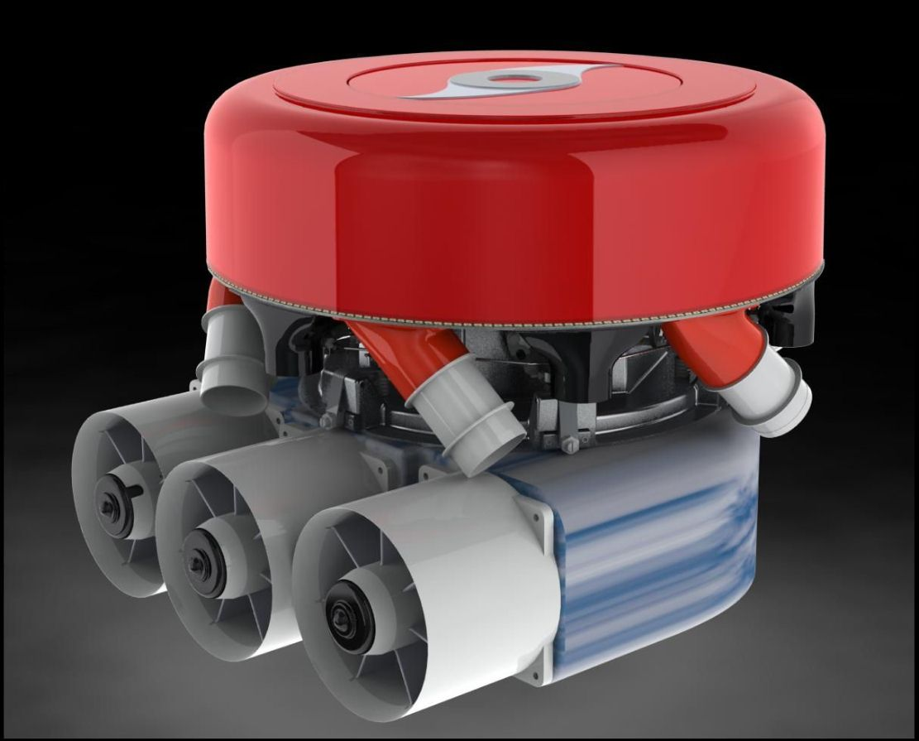

Mark V – Flow Diagram

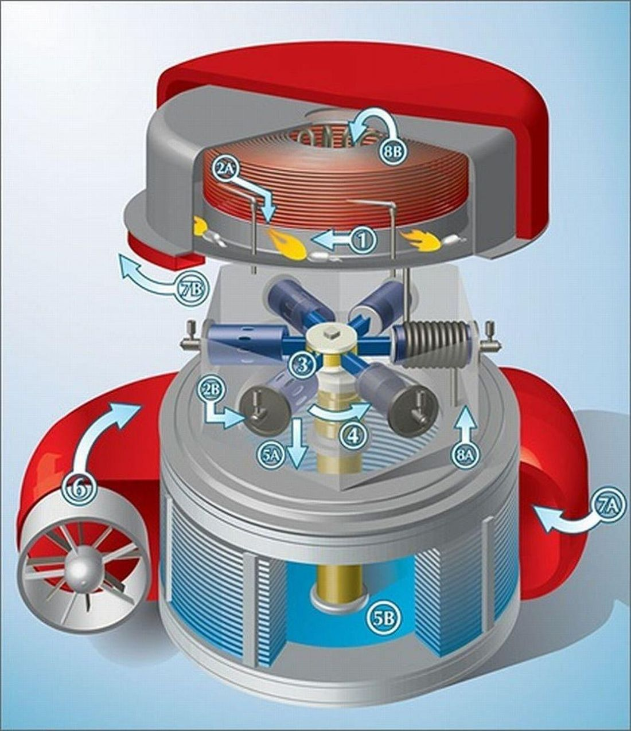

The Mark V Cyclone Engine – Internal Construction.

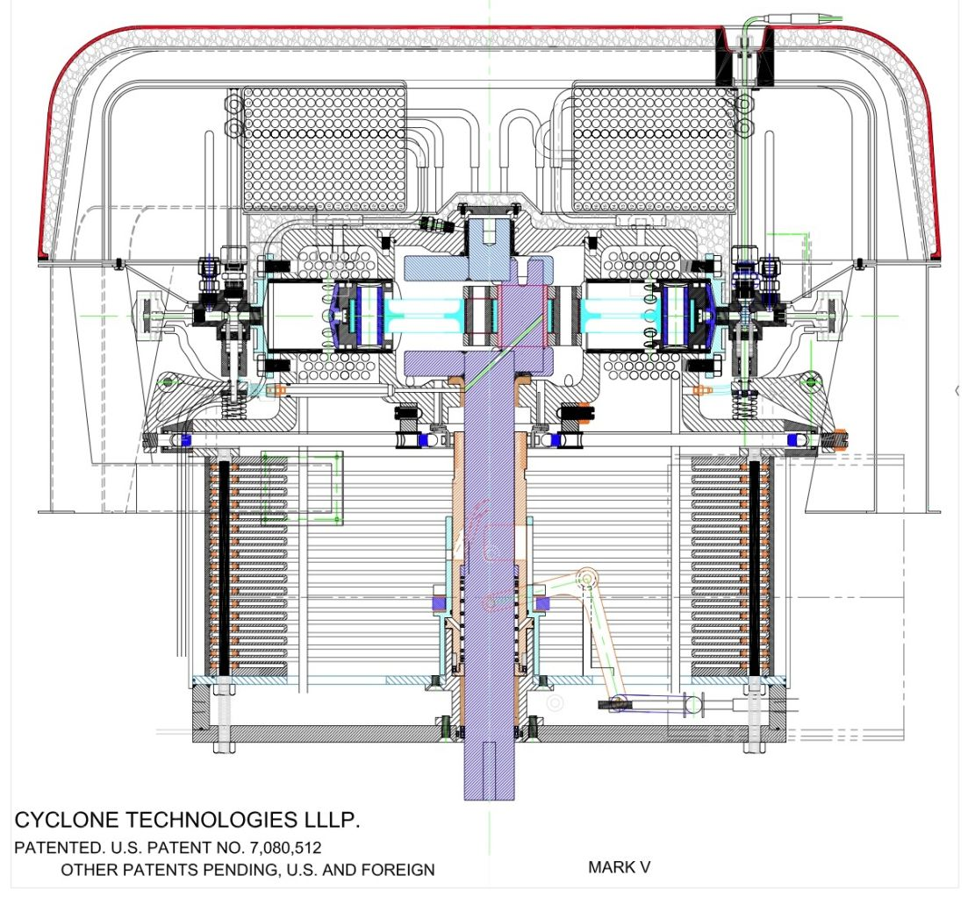

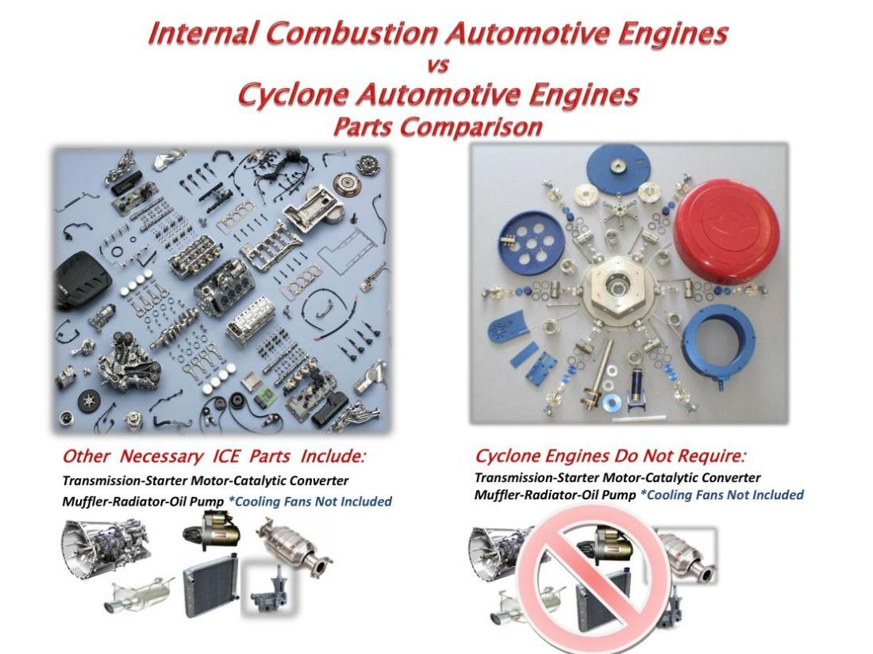

Author, James D. Crank, is widely considered one of the foremost experts on automotive steam engine systems. During his long career with Lockheed, Mr. Crank worked as a Senior Research Specialist on many important projects, including: supersonic gas gun design for shock wave testing of materials, engine development and evaluation for the Ground Vehicles Department, flywheel kinetic energy storage for municipal buses, in plant vehicles and mine locomotives with development and test lab management, primary battery systems development for the Triton II missile, battery systems for the Hubbell Space Telescope, heat shield testing equipment for the Mercury and Apollo manned space systems, dynamic solar and nuclear space power systems for SDI and a number of classified military programs. Mr. Crank was also a Senior Research Engineer at the Stanford Research Institute where he worked on developing explosive cladding of materials for cylinder construction for Porsche and Mercedes-Benz, ceramic armor impact test systems among other classified projects. Mr. Crank has over 50 years experience in the study, design, construction, restoration, repair and driving of various steam cars, including the total redesign of the complete crankcase assembly and cylinders for the Series E Doble steam cars (with 11 sets constructed). The design and construction of the previous speed world record holding steam car, the Barber-Nichols car. He served as a consultant on steam car restoration to Harrah Automobile Collection, Nethercutt Collection, Jay Leno Collection, Stephen Finn Collection, and participated in the Besler-General Motors steam car conversion project among others and as a consultant to the State of California on the steam bus development and Clean Air Car programs. He is the owner, principal historian and president of the Doble Steam Motors Corporation, and is currently completing a book about the history of the Doble steam car and its founding family.
Information about Cyclone Power Technologies, based in Pompano Beach, FL, can be found at: www.cyclonepower.com.
Soot is a result of momentary imbalance in the air/fuel ratio. Reports and experience have identified the universal use of turbo-charging with the Diesel engine and one particular transition point that is the root cause of the soot production. Open the throttle quickly and the fuel flow rate is immediately increased; but the turbocharger has not spooled up to the point where the excess air is produced. This condition causes an over rich mixture and soot is the result, the belch of black smoke when an older big truck takes off from a stop. Manufacturers are now including variable turbine inlet vane turbochargers in an effort to maintain the right air/fuel ratio at all speeds and loads. Or smaller twin turbochargers that spool up faster. Plus the inevitable present panacea that all manufacturers turn to in desperation, digital electronic fuel injection management.
A mandate by the Port of Oakland that all Diesel trucks that service the docks must be equipped with NOx and soot elimination exhaust systems on Jan. 1, 2010 resulted in an interesting situation. The independent truck owners and the fleet operators said that they would shut down the Port unless the Port Authority came up with a permanent solution, abandon the mandate, or provide the financing for these new exhaust systems at an interest free cost to the owners. This is yet an unresolved situation as far as it is presently known. Commerce cannot allow these ports to be totally shut down. The resolution to all of this has not been noted in the local press as yet, thanks to their usual lack of any follow-up about the possible solution to this. The only response noted was that the Port Authority was “studying” the matter.
The Stirling cycle hot air engine and the Brayton cycle gas turbine could also satisfy this condition. The small gas turbine is ruled out due to high fuel consumption particularly at part load, a rather narrow operating range, a NOx problem along with high production costs and extreme operating temperatures and speeds if any reasonable efficiency is to be seen. The Stirling is also very expensive, is not self starting, is most difficult to throttle and is large for the power production a specific engine will produce. Ford tried it in vehicles during the Clean Air Car Program and gave it up.
New developments in stop-and-start technology for IC engines are in process and claim to increase fuel mileage by automatically turning off an engine when at rest, but at what added sticker cost remains to be seen, along with inevitable reliability, complex service problems and driver annoyance of being stranded when they do not work. Hybrids also feature such a quality, converting to electric use in city driving. Such systems are seeing production because the technology is well known, time to introduce it in new cars is minimum and corporate risk is minimized. Along with being systems that rapidly can be put into production and meet the Government pollution and fuel mileage mandates with a minimum of corporate funding.
? The electric motor also produces its greatest torque at starting, making it with respect to power curves, a good power source for automobiles. However, to generate the amount of power needed for a standard-sized passenger vehicle, SUV or truck, the battery packs required are impractically large, heavy and expensive. Only a city use vehicle is considered to be semi practical.
Cyclone’s engine is currently protected by seven patents in the U.S., plus more internationally, including: US Patent No. 7,080,512 B2 Heat Regenerative Engine (2 issued), US Patent No. 7,407,382 B2 Steam Generator in a Heat Regenerative Engine, US Patent Allowance for Valve Controlled Throttle Mechanism, US Patent Allowance for Engine Reversing and Timing Control, US Patent Allowance for Centrifugal Condenser, US Patent Allowance for pre-heater coils.
9 The control system difficulties of such steam generators are not usually well understood by modern steam car developers. Tube burnout and surging are common failure modes. A most satisfactory solution is to use the Lamont style steam generator in preference to the Doble system. This use neatly side steps all the control problems of the monotube steam generator and provides a great improvement in the amount of steam produced per hour from each square foot of heating surface.
One must also pay strict attention to employing only the shortest possible ports from the inlet valve to the cylinder and keeping them as straight, short and as smooth as possible. Turbulent flow is to be avoided, only the lowest possible flow losses in the porting. In the best practice, the inlet valve opens directly into the cylinder with no intercommunicating port at all. This also includes using the highest practical compression ratio and thus a minimum clearance volume.
Prof. J. Stumph, “The Una-Flow Steam-Engine”, Second Edition, 1922.
? When receiving a heavy charge current, or a large current demand like hill climbing or accelerating, the Li-ion batteries demand a cooling system, or they can easily catch fire. Another added cost, safety, reliability and weight problem that cannot be ignored.
Many people, accompanied by howling dissention by environmental groups, suggest increasing the number of nuclear plants, which is in the opinion of this author, a most suitable power source along with greatly expanded solar and geothermal. Many learned studies suggest that efficient hot gas closed Brayton cycle turbine generators replace the present breeder reactors and steam turbines with pebble bed reactors as the much safer nuclear heat source. These do not generate radioactive waste products like the present nuclear reactors do, only heat. It remains to be seen, however, whether the public will accept and the politicians will push for new, safer nuclear power in the future.
The California Steam Bus Project was designed to demonstrate the potential of low-emission, quiet steam engines in public transit service. The three contractors noted above replaced the original diesel engines in urban buses with external combustion engines. Results found that indeed exhaust emissions were considerably lower than the 1975 California requirements for heavy-duty vehicles, but because these engines used low efficiency technologies, fuel consumption was far from optimal, often well over twice as much of the Diesel engines they replaced. Such problems would be corrected with the Schoell cycle engine.

