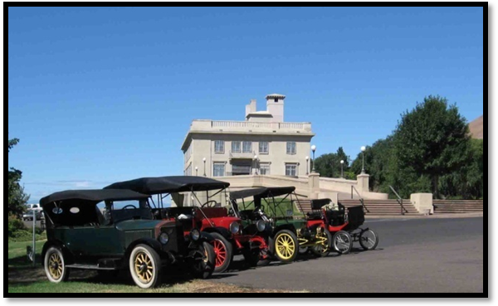
Columbia River Gorge
Steam Automobile Tour
NW Chapter of the Steam Automobile Club of America
July 8-11, 2009
The NW Chapter of the SACA is sponsoring a tour of the area in and around the eastern end of the Columbia River Gorge National Scenic Area. The tour will stage out of the Shilo Inn in The Dalles Oregon. The first day combines workshop time with a short tour. Tours on the following days will range from about 50 to 100 miles in length.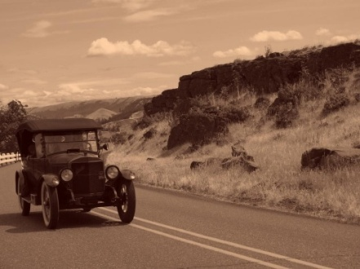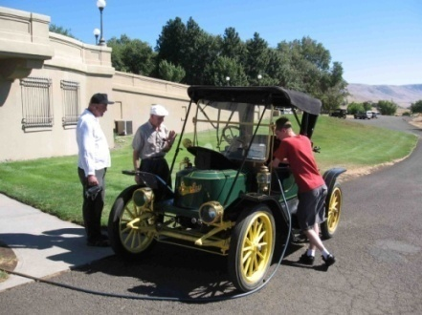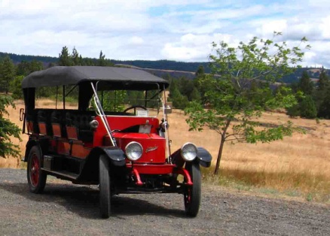
This tour is open to all members of the Steam Automobile Club of America. To Sign-up for the tour or for additional information please contact:
Eric Gleason PO Box 1065 The Dalles Oregon 97058 Phone (541) 296-1802 Or email to: 2009columbiariversteamtour@gmail.com
A block of 20 rooms have been held at the Shilo Inn, to make your reservations please call (541) 296-5502
Quoted rates are $92.95 for a single Queen size bed and $112.95 for a room with two queen sized beds. Rates do not include the 9% room tax. Camping facilities and other motels are also available in the area.

Steam Car Tour and Clinic
July 8-11, 2009
The Dalles, Oregon

REGISTRATION FORM

NAME:______________________________________

ADDRESS:___________________________________

____________________________________

____________________________________

EMAIL:______________________________________

PHONE NUMBER:____________________________

NUMBER OF PEOPLE IN YOUR PARTY:_____________

DO YOU PLAN TO BRING A CAR, DISPLAY OR GIVE A TALK?

Mail to:
Eric Gleason
PO Box 1065
The Dalles, Oregon 97058
Or email: 2009columbiariversteamtour@gmail.com

